What is postman?

It is tool to perform api testing.

What is client : It is a computer

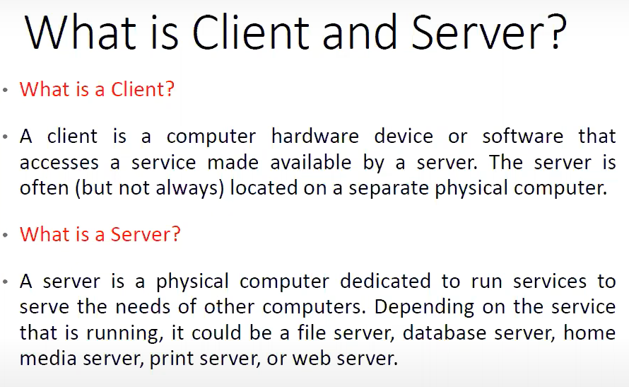

3 tire architectute

Presentation layer =========🡺 Business Logic ==========🡺Database Layer

(Gui testingSelenium) (API Testing) (Database testing)

**Collection:** Contains multiple requests

<https://reqres.in/api/users?page=2> 🡺 URL ( Uniform resource locator)

🡺URI (uniform resource identifier)

<https://reqres.in> 🡺 domain

/api/users 🡺 path parameter

?page=2 🡺query parameter

Instal post man

Install newman

Go to cmd prompt 🡺 npm install -g newman

Request

GET

POST 🡪 insert 🡪 request body/ request payload

PUT 🡪 update 🡪 request body/ request payload

DELETE

Every request wil get the response in json/html/xml/text etc

One a HTTP request is executed

Look for

http response

Status

Time

Data size ( how many records)

Data type

Headers 🡪 check for proper headers

Cookies

Test results

* json path finder chrome extension 🡺 add to chrome

|  |
| --- |
| pm.test("Valid Last name", function () {  var jsonData = pm.response.json();  pm.expect(jsonData.data.last_name).to.eql("Weaver");  });  pm.test("Valid Email", function () {  var jsonData = pm.response.json();  pm.expect(jsonData.data.email).to.contains("@");  });  pm.test("Valid support text", function () {  var jsonData = pm.response.json();  pm.expect(jsonData.support.text).to.have.length.greaterThan(0);  }); |

**Authorizing Requests**

Authorizing requests include authenticating the identity of the client who sends the request and verifies whether the client is allowed to access and conduct the endpoint operations. APIs use authorization details to make sure that the client requests access data safely.

Several authorization types are available in Postman that you can use while creating an API.

You need to ask the provider for any authorization details you require while using third party API.

**Status Code**

A status code defines the status of the request. On entering URL, a mistake can be typed in the URL, or there may be a server-side problem. Status code is used to know about what went wrong and where you made a mistake. There are different status codes, and each of the status codes has different meanings.

Let's see some standard status codes:

200: This code is used for a successful request.

201: For a successful request and data was created.

204: For empty response.

400: This is used for Bad Request. If you enter something wrong or you missed some required parameters, then the request would not be understood by the server, and you will get 400 status code.

401: This is used for Unauthorized Access. If the request authentication failed or the user does not have permissions for the requested operations, then you will get a 401 status code.

403: This is for Forbidden or Access Denied.

404: This will come if the Data Not Found.

405: This will come if the method not allowed or if the requested method is not supported.

500: This code is used for Internal Server Error.

503: And this code is used for Service Unavailable.

**Time**

Time is the duration between the sent request time and the received response time. Means, this is the duration which the response took after we sent the request and received the response.

This is very useful sometimes because many projects have a Service Level Agreement (SLA). The time shown here is not the actual time that the request will take. It is just approximate time, but you can consider this as an actual time.

**Size**

Size is the size of the response when it is processed within memory. This response size includes the size of response, cookies, headers, and everything that has been transmitted along with the response.

**Response Body**

A Response body is the body of the response, which actually contains the response content that has been sent from the server. In this section, you can see the web page code is sent to us as a response.

Format Type

Each request has a defined response to it as defined by the Content-Type header. That response can be in any format.

You will see that we have multiple format types:

JSON

XML

HTML

Text

Auto

**Cookies**

Cookies are the small size of files which contain the information related to server files or website pages. Once you open the website for the first time, a cookie file will download on your system. This cookie has some information which will be used by the same site when you visit again. This allows the website to give a specific response and specific information according to your last visit.

Postman offers you to see the cookies that have been sent from the server as a response. We cannot make any changes to the cookies since we got from the server.

**Headers**

Headers are the extra information that is transferred to the server or the client. In the postman, headers will show like key-value pairs under the headers tab.

**Request Parameters in Postman**

Request parameters are used to send additional information to the server. A URL contains these parameters. There are two types of parameters:

**Query Parameter**: These are appended to the end of the request URL, Query parameters are appended to the end of the request URL, following '?' and listed in key-value pairs, separated by '&' Syntax:

?id=1&type=new

**Path Parameters**: These are part of the request URL, which are accessed using the placeholders preceded by ':' Example:

/customer/:id

There are two ways of setting query parameters on a request in Postman.

**POST Request in Postman**

The post is an HTTP method like GET. We use this method when additional information needs to be sent to the server inside the body of the request. In general, when we submit a POST request, we expect to have some change on the server, such as updating, removing or inserting.

One of the best examples of using POST request is the login page of Facebook or the login page of other sites; you send your personal information such as the password to the server. The server creates a new account with the same information and that account, and the information is added permanently on the Facebook server.

The POST request is a fundamental method, and this method is mostly used when a user wants to send some sensitive data to the server like to send a form or some confidential data.

**Important points of the POST request:**

POST requests will not take the cookies.

POST requests are not left in the history of browsers.

We cannot bookmark the POST requests.

There is no restriction of data length in POST requests.

Sending Body Data

Since now, you know that we need to send the body data with requests whenever you need to add or update structured data.

Select the POST request method, and go to Body option where we have different options for sending data:

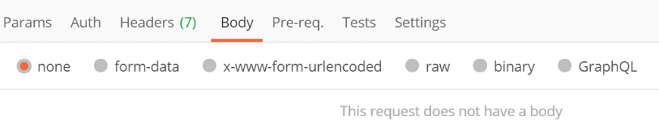

POST Request in Postman

Here you have:

none

form-data

x-www-form-urlencoded

raw

binary

GraphQL

### form-data

form-data sends the form's data. Such as the information you enter while filling out a form. To send these details, write them as key-value pairs. Here, the key is the name of the entry, and value is the value of the entry you are sending. Follow the following steps:

* Select form-data.

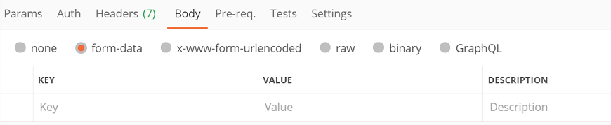

* Add the KEY-VALUE pair.

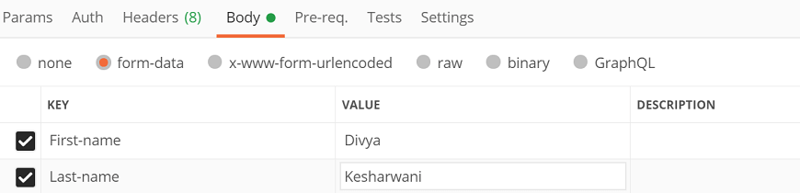

### x-www-form-urlencoded

It works similar to form-data. The only difference between both of them is that, when you sent the data via x-www-form-urlencoded, the url is encoded. Encoded indicates that the transmitted data is converted to various characters so that unauthorized persons cannot recognize the data.

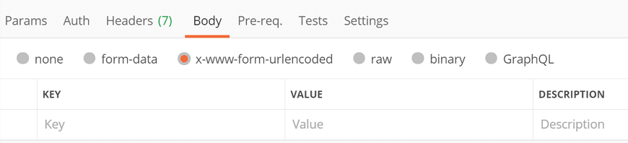

### Raw

This is a very useful option while sending the body to the POST method. Here the body data will be presented in the form of a stream of bits.

In the above examples, we already discussed the raw. So, we will not discuss it again.

### Binary

Binary is used to send the data in a different format. Such as a file, image, etc. To use this option, select binary and then click on Select File to browse any file from your system.

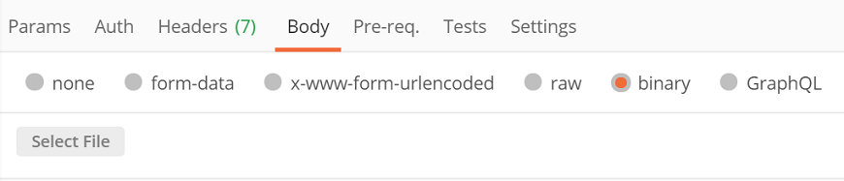

### GraphQL

Through this option, you can send the [GraphQL](https://www.javatpoint.com/graphql) queries in your postman requests by selecting the GraphQL tab in the request Body.

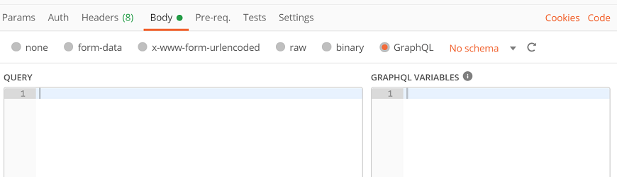

Here you need to enter the code in the section of QUERY and any variable in the section of GRAPHQL VARIABLES.

# **Cookies in Postman**

Cookies are the files with very small size, which contain the information for server files or website pages. When you firstly open the website, a cookie file will be downloaded to your machine. This cookie contains some details; the same site can use the details when you visit again. This allows the website to offer a detailed response according to your last visit.

In postman, we can see the cookies that were sent as a response from the server. We cannot make any changes to the cookies since we got from the server.

### Cookies Manager

To start the work on cookies in postman, open the Cookies option from the right side of the postman window under the Send button.

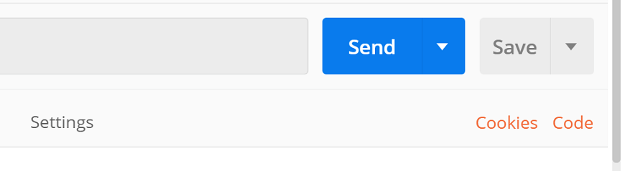

When you select cookies, then it will open the Manage Cookies window. Here you can see the domains list and cookies linked with them.

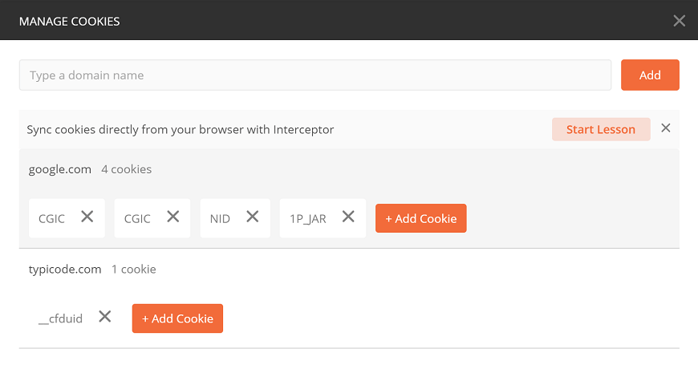

## **Create a Cookie**

In [postman](https://www.javatpoint.com/postman), we can also create new cookies for the domain. To create a new cookie, select the 'Add Cookie' button.

Here, I will take the [www.google.com](https://www.google.com/) domain.

Enter the domain name in the [URL](https://www.javatpoint.com/url-full-form) text field and click on the Add button.

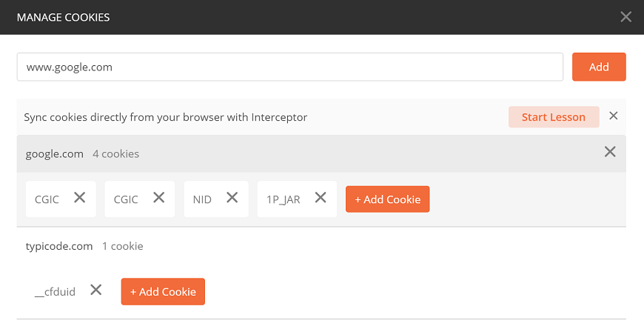

Since we already have a google.com domain in the inventory, we will directly add the cookies. Click on '+Add Cookie.'

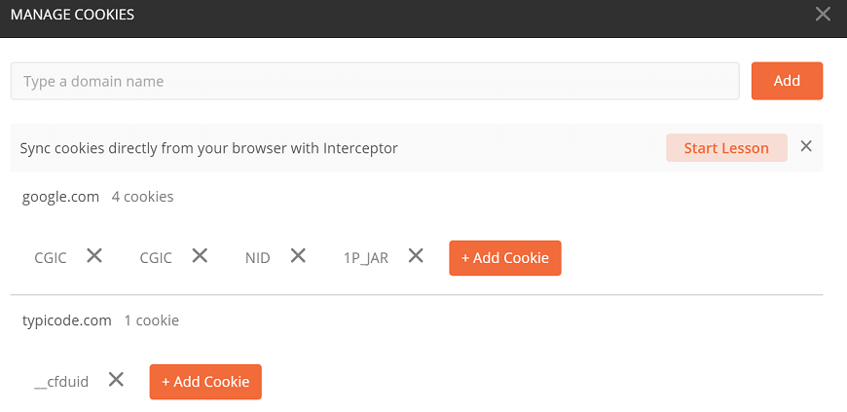

A new text box will open where some default values are already written. Edit those values as given below example:

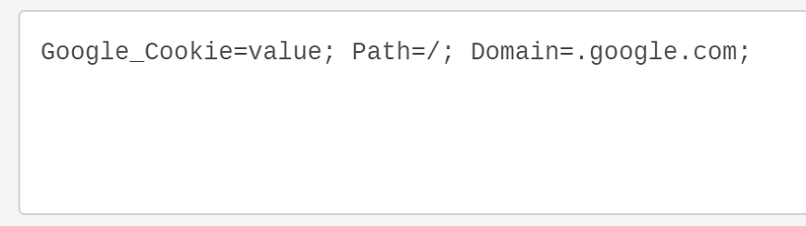

Click on the Save button.

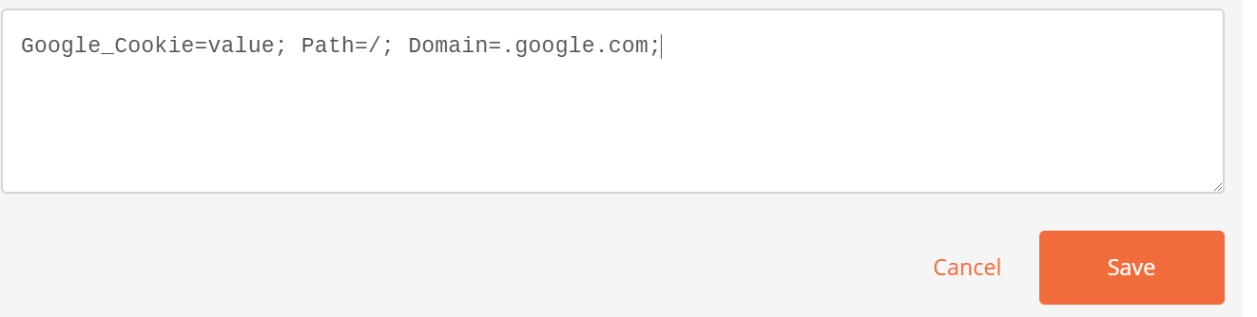

Here you can see your newly created cookie.

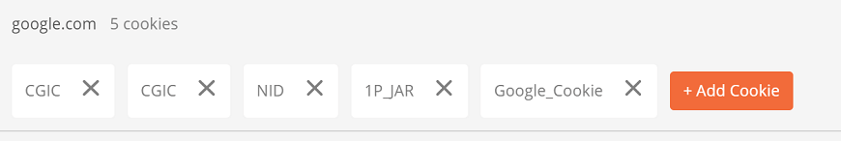

Close the panel. And enter the URL www.google.com in the URL text field and click on send. Go to the Response section and click on the Cookies tab. We can see the cookie which we have added here.

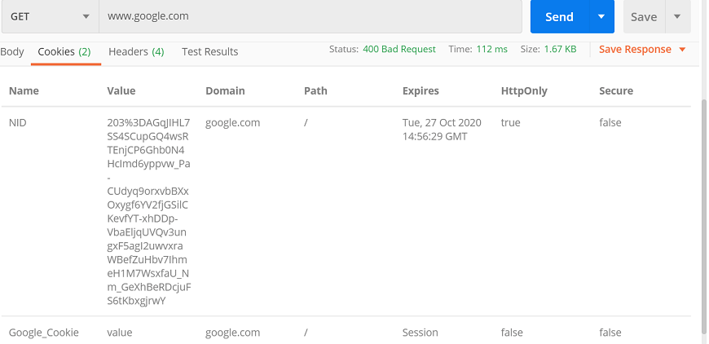

### Updating a Cookie

In postman, we can update the cookies. Click on 'Cookies' to change an existing cookie and pick the domain from the domain list in the MANAGE COOKIES section, then click the cookie you want to update. We can change any property, and click Save to update.

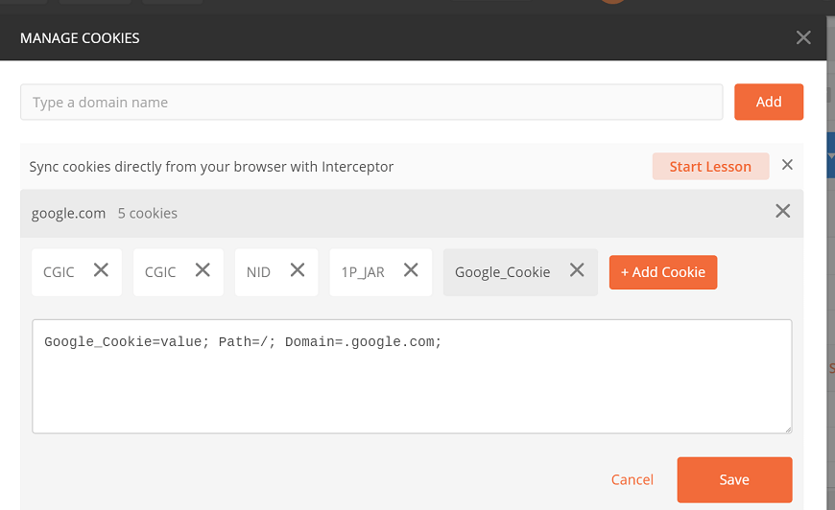

### Deleting a Cookie

Deleting a cookie is very easy. To delete an existing cookie, click on 'Cookies,' and in the MANAGE COOKIES section, select the domain from the domain list, go to the cookie you want to delete, and click on X option. Your cookie will be deleted.



**Postman Intro to Collections**

Collection in Postman means a group of API requests that are already saved in the Postman and can be arranged into folders. Any number of folders can be created inside a collection.

Putting similar requests into folders and collections helps the client in better organization and documentation of their requests.

All the APIs requests can be stored and saved within a collection, and these collections can be shared amongst the team in the Postman workspace.

**Advantages of creating collections**

**Easy APIs import and export**

A collection can be imported or exported. Thus it can save time for transferring the requests.

**Request categorization**

Requests can be grouped into folders and collections for easy access.

**Passing data among requests**

Scripts can be used to pass data between API requests.

**Running collections/folders.**

You can run individual requests or folder or collection as a whole in the Postman.

**API documentation**

Postman provides you an option to add a name and description to your request, folder, and collections.

**Building Test suits**

Test scripts can be added to requests, and integration test suites can be built.

**Time-saving**

Setting any variable for collections will automatically apply the same to the folders generated under the collection and requests; thus, it saves time.

**Variables in Postman**

Postman variables work in the same way as that of the programming variables. These are the symbols capable of taking various values. You can store the values in variables and can use it throughout in requests, environments, collections, and scripts.

Variables in Postman increase the user's efficiency to work and decrease the errors.

**Environment in Postman**

A collection of key-value pairs is called an environment. Each name of the variable represents its keys. And referencing the name of the variable allows you to access its value.

It is a set of variables that differentiate among the requests. Such as, we can have an environment for testing, one for development and another for production. We can change the value of the variables to pass the data between requests and tests.

**Variable Scopes**

Variable scope is the boundary within which these variables can be accessed and executed. The following variable scopes are supported by Postman, which is used for different tasks. The narrowest variable scope is Local, and then next is Data, Environment, Collection, and the broadest one is Global.

## **Variable Scopes**

Variable scope is the boundary within which these variables can be accessed and executed. The following variable scopes are supported by Postman, which is used for different tasks. The narrowest variable scope is Local, and then next is Data, Environment, Collection, and the broadest one is Global.

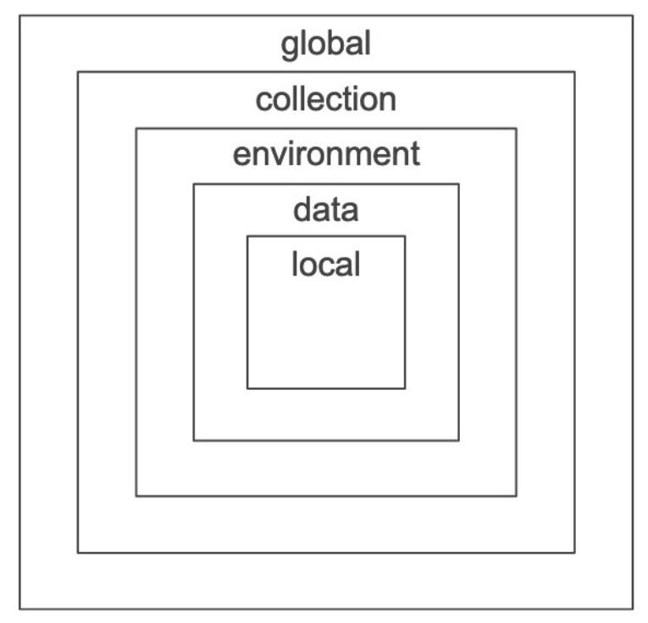

In case, the variable name is the same, in two scopes with a different value, then the value of the narrowest variable scope will be used while running the request. Let's say the name of both local and global variables is **My Variable.** Then Postman will use a local variable value to run the request, as a local variable is the narrowest variable scope.

Let's see these variable scopes one by one:

* **Local Variables**  
  These are temporary variables that will only function inside the environment they were created in. When you change the environment, the variable will stop its access, and an error will occur.
* **Collection Variables**  
  These are independent of environments and are available for all the requests in a collection.
* **Environment Variables**  
  These are the most used variable scope in Postman. At a time, a single environment can be active. They are bound to a specified environment used to execute the request.
* **Global Variables**  
  These are independent of environments and function outside the environment. Users are not required to create an environment for global variables. Through global variables, we can access data between collections, test scripts, requests, and environments.
* **Data Variables**  
  Data variables come from external CSV and JSON files to define data sets that you can use while collections are running through Newman or the Collection Runner.

**Postman Dynamic Variables**

<https://learning.postman.com/docs/writing-scripts/script-references/variables-list/>

Dynamic variable, as the name suggests, generates random data to your API requests and collection run. It is like a random library in a programming language. It generates random data each time in response like a random number, alphabets, alphanumeric or color, etc.

A dynamic variable name starts with '$.' In the request URL section, a dynamic variable should be written in {{__}} format.

Let's say you have to pass an integer number from 1 to 1000, so for that, you need to add {{$randomInt}}.

Usage

**console.log(pm.variables.replaceIn('{{$randomInt}}'));**

## **Some important Dynamic Variables are**

### Numbers, Texts and Colors

|  |  |
| --- | --- |
| **Variable Name** | **Description** |
| $randomAlphaNumeric | A random alphanumeric character |
| $randomInt | A random integer between 1 and 1000 |
| $randomColor | A random color |
| $randomHexColor | A random hex value |
| $randomAbbreviation | A random abbreviation |
| $randomBoolean | A random boolean value like true or false |

Domains, Username, and Emails

|  |  |
| --- | --- |
| **Variable Name** | **Description** |
| $randomUrl | A random URL |
| $randomUserName | A random username |
| $randomEmail | A random email address |
| $randomDomainName | A random domain name |
| $randomDomainSuffix | A random domain suffix |

Internet and IP address

|  |  |
| --- | --- |
| **Variable Name** | **Description** |
| $randomIP | A random IPv4 address |
| $randomIPV6 | A random IPv6 address |
| $randomPassword | A random alphanumeric password of 15-character |
| $randomUserAgent | A random user agent |
| $randomProtocol | A random internet protocol |
| $randomMACAddress | A random MAC address |

Files and Directories

|  |  |
| --- | --- |
| **Variable Name** | **Description** |
| $randomCommonFileName | A random file name |
| $randomFileName | A random file name (includes uncommon extensions) |
| $randomFileExt | A random file extension (includes uncommon extensions) |
| $randomFileType | A random file type including uncommon file types |
| $randomCommonFileType | A random, common file type |
| $randomCommonFileExt | A random, common file extension |
| $randomDirectoryPath | A random directory path |

Images

|  |  |
| --- | --- |
| **Variable Name** | **Description** |
| $randomImage | A random image |
| $randomImageUrl | A URL for a random image |
| $randomAnimalsImage | A URL for a random animal image |
| $randomCityImage | A URL for a random city image |
| $randomFoodImage | A URL for a random food image |
| $randomTransportImage | A URL for a random transportation image |
| $randomSportsImage | A URL for a random sports image |
| $randomTechnicsImage | A URL for a random tech image |

**Scripts**

In Postman Scripts are the lines of code that allow you to automate an API test. It offers you to write pre-request and test scripts.

Before sending a request, a pre-request script will run and,

After receiving a response, test scripts will run.

In Postman, we can write the tests, pass the data between the requests, and change the parameters. It allows adding test script and pre-request script to a collection, a folder, a request, or a request not attached to a group.

## **Postman Sandbox**

To write the script in Postman, we use Postman Sandbox.

[Postman](https://www.javatpoint.com/postman) sandbox has been written in [Javascript](https://www.javatpoint.com/javascript-tutorial). It is an execution environment. Since the sandbox has written in Javascript, therefore, it will only receive a script written in Javascript.

Hence, we have to write the script in javascript to make the code executable in Postman.

## **Execution Order of Scripts in Postman**

In Postman, the order of script execution for **a single request** is as follows:



* A pre-request script associated with a request will execute before sending the request.
* Test script associated with a request will execute after sending the request.

The order of script execution for **every request in a collection** is as follows:

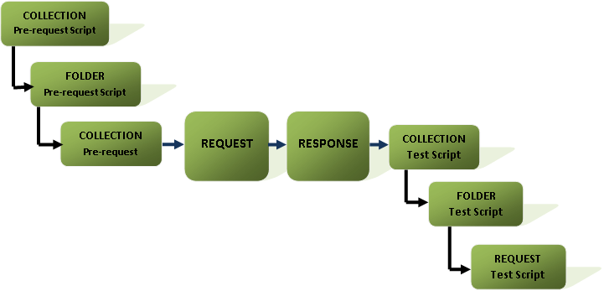

* Before every request in the collection, a pre-request script associated with a collection will run.
* Before every request in the folder, a pre-request script associated with a folder will run.
* After every request in the collection, a test script associated with a collection will run.
* After a request in the folder, a test script associated with a folder will run.

The scripts should always run according to the following hierarchy for every request in a collection:

* Collection level script
* Folder level script
* Request level script

The same order will be applied for both pre-request and test scripts.

Go to the **Tests** Write the following code inside the editor:

1. pm.environment.set("u", "Hello");

This will create a variable inside the selected environment with the name "u" and value "Hello".

If you try to get a variable that is not define, the o/p is undefined

**pm.test()**

This function writes the conditions of the test in the postman test sandbox. Writing tests within this feature helps you to correctly name the test and ensure that the rest of the script is not interrupted in case of any errors.

This function has two arguments, first is the test name (as a string), and second is a function which returns a Boolean value.

**pm.expect()**

The pm.except() function is used to print the test result messages in a different format. This function makes the test readable, and even we can manage data assertions from a variable or response.

Through this function we can test the request environment, as given below:

1. pm.test("environment to be production", function () {
2. pm.expect(pm.environment.get("env")).to.equal("production");
3. });

Another example is:

1. // example using response assertions
2. pm.test("Status Ok", function () {
3. pm.response.to.not.be.error;
4. pm.response.to.have.jsonBody("");
5. pm.response.to.not.have.jsonBody("error");
6. });

### pm.response.to.be.*

This is an object, offers shorthand for the tests based on commonly used response.

1. // example using pm.response.to.be*
2. pm.test("Response", function () {
3. // assert that the status code is 200
4. pm.response.to.be.ok;
5. pm.response.to.be.withBody;
6. pm.response.to.be.json;
7. });

We can also set a nested object as an environment variable:

var array = [1, 2, 3, 4];

pm.environment.set("array", JSON.stringify(array, **null**, 2));

var obj = { a: [1, 2, 3, 4], b: { c: 'val' } };

pm.environment.set("obj", JSON.stringify(obj));

**Getting an Environment Variable**

1. pm.environment.get("variable_key");

**Clear an Environment Variable**

1. pm.environment.unset("variable_key");

## **Collection**

**Setting a Collection Variable**

1. pm.collectionVariables.set(variableName:String, variableValue:String);

**Get a Collection Variable**

1. pm.collectionVariables.get(variableName:String);

**Clear a Collection Variable**

1. pm.collectionVariables.unset(variableName:String);

## **Globals**

**Setting a Global Variable**

1. pm.globals.set("variable_key", "variable_value");

**Getting a Global Variable**

1. pm.globals.get("variable_key");

**Clear a Global Variable**

1. pm.globals.unset("variable_key");

## **Response Handling**

**Search for a String in Response Body**

1. pm.test("Body Contains", function () {
2. pm.expect(pm.response.text()).to.include("search_string");
3. });

**Check if Response Body is equal to a String**

1. pm.test("Body is correct", function () {
2. pm.response.to.have.body("response_body_string");
3. });

**Check for a JSON Value**

1. pm.test("Your test name", function () {
2. var jsonData = pm.response.json();
3. pm.expect(jsonData.value).to.eql(100);
4. });

**Check if Content-Type header is present**

1. pm.test("Content-Type header is present", function () {
2. pm.response.to.have.header("Content-Type");
3. });

**Response Time is less than 200 ms**

1. pm.test("Response time is less than 200ms", function () {
2. pm.expect(pm.response.responseTime).to.be.below(200);
3. });

**Status code is 200**

1. pm.test("Status code is 200", function () {
2. pm.response.to.have.status(200);
3. });

**Code name contains a string**

1. pm.test("Status code name contains a string", function () {
2. pm.response.to.have.status("Created");
3. });

**Successful POST request status code**

1. pm.test("POST request Successful ", function () {
2. pm.expect(pm.response.code).to.be.oneOf([201,202]);
3. });

**Workflows in Postman**

POSTMAN workflow is the order of request execution within a collection. When you run the collection directly, then the requests are either executed randomly or executed serially. But we can also set the priority of the request, and we can also choose the order of execution of request means we can set which request should be executed when. This feature is called workflow in Postman.

Postman provides a feature to control the workflow of requests in the collection, and the feature is called Collection Runner (or Runner).

Collection runner runs sequentially by default

**Asserts in Postman**

The assertion checks whether the given predict is true or false in any programming language. A predict is a Boolean expression with the value true or false. That means assertion is nothing but code that can be used to check or analyze the response that is received from the server.

An assertion is a code written in javascript in Postman that is executed after receiving the response.

Assertions help us to assert that expected and actual values should match during a test run. If the actual and expected values don't match, then the test will fail with the output pointing to the failure.

# **Chai Assertion Library**

Chai assertion library is an external javascript library used to write assertions. Compared to what we write directly in javascript, this assertion library needs less time & effort and easy use.

Chai assertion library is available by default in the [Postman](https://www.javatpoint.com/postman). So when you are writing chai assertions, then don't worry about other processes of installation. The main feature of Postman assertions is that they write the tests with English sentences, which is human readable. So it is very easy to read and user friendly.

If you would like to learn more about the Chai Assertion Library, there is an official website for that. You can visit this <https://www.chaijs.com/>.

### Writing Assertions using Chai Assertion Library.

Copy the following URL in the [URL](https://www.javatpoint.com/url-full-form) text field.

1. www.javatpoint.com

**Example 1:**

* Go to the Tests tab and write the following code in the Tests editor.

1. pm.test("If 100 equal to 200", function(){
2. pm.expect(100).to.eql(200);
3. });

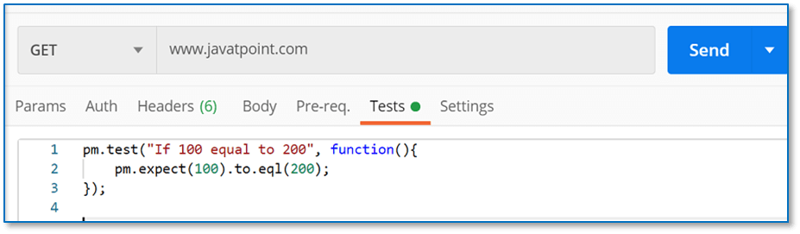

* Click on Send and see the Test Results from the response section.

AD

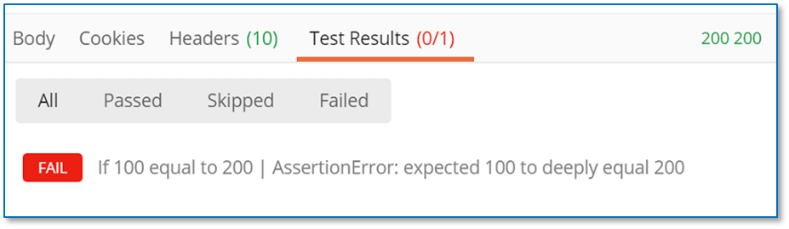

In the above example, we are checking that if 100 is equal to 200 or not. The response is failed, which is obvious.

Just edit the code with the following code and see the response again.

1. pm.test("If 100 equal to 100", function(){
2. pm.expect(100).to.eql(100);
3. });

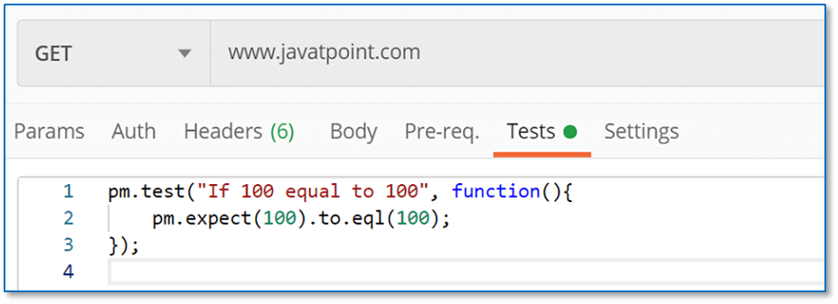  
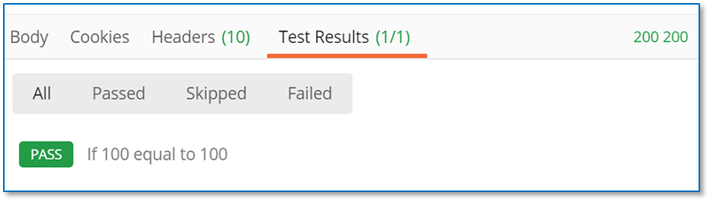

Since 100 equal to 100. The test is passed.

**Example 2:**

Here, we will check the given number is in an array or not.

* Open the tests tab and write the following code:

1. pm.test("Number included", function(){
2. pm.expect([100,200,300]).to.include(300);
3. });

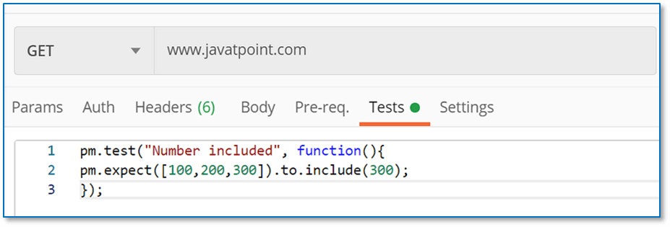

* Press send and see the Test Results tab from the response.

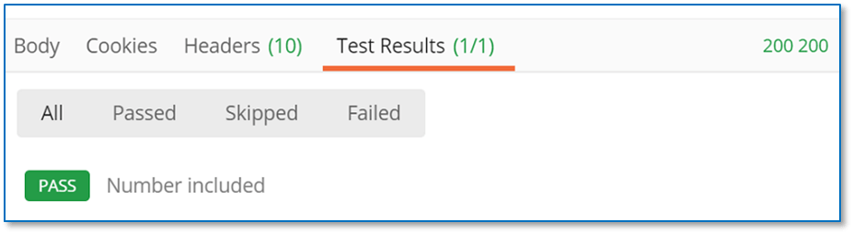

Here, you can see that the test is passed because, in the array list of 100, 200, and 300 has 300.

**Example 3:**

In this assertion, we will verify the object.

* Open the tests tab and write the following code:

1. pm.test("Compare Name", function(){
3. let x= {
4. "name" : "Nikita"
5. };
7. let y= {
8. "name"  : "Nikita"
9. };
11. pm.expect(x).to.eql(y);
12. });

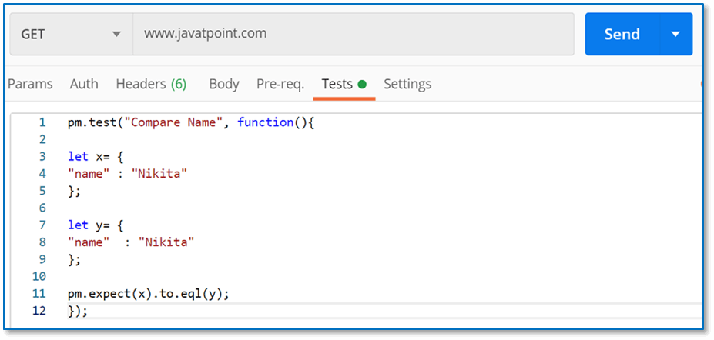

* Click on the Send button and see the Test Results from the response.

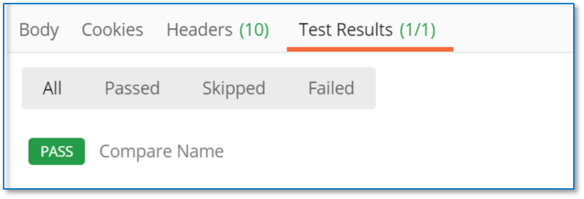

The test is passed because on both objects, names are equal.

In the above code, we have used eql(). Postman offers both methods eql() and equal(). But both methods are different. equal() is used to compare the objects, and eql() is used to compare the properties of the objects. In this case, eql() compared the name property of the object.

Try to edit the last line of code with pm.expect(x).to.equal(y), and see the response.

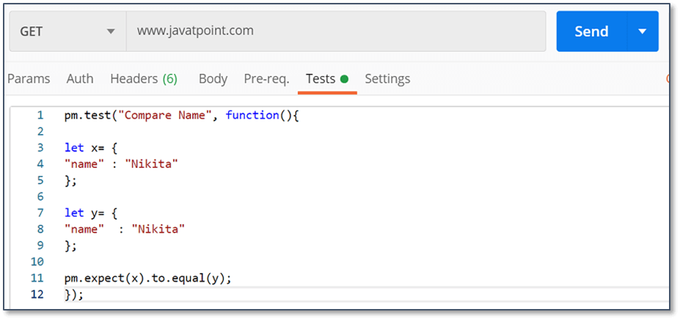  
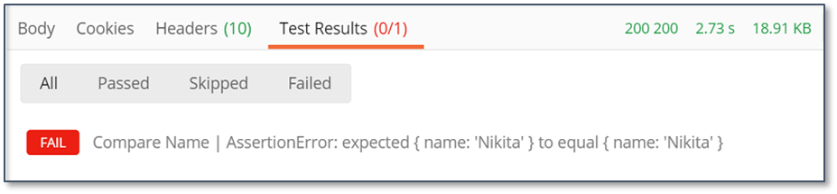

The above test failed because we have used equal(), which compares the object, not the property of the object.

# **Intro to Mock Servers**

* The mock server is a fake server that simulates as a real server to help the users for testing and checking their APIs and APIs responses.
* During the various API testing, a Mock server is used when specific responses are required to be received that are not readily available on the web servers or for certain testing, which cannot be done due to security issues on real servers.

## **How Mock Server Works**

When you send the request then MockServer receives that request, it matches the request against the specified requirement, and if no matches are found, it will proxy the request, if possible. The request would otherwise return a 404.

For each Received Request:

* Find matching expectations and perform an action.
* If the request does not match the expectation, then it will proxy request.
* if not a proxy request will return 404

## **Benefits of Postman Mock server**

* To check your own API during development and before you make that API live on your organization's server.
* To get faster reviews and bugs.
* Without any authentication, any type of request can be made into the server.
* To test the dependencies inside the API until they are open to everyone.
* For QA engineers, use this to check or isolate external dependencies and check the integration.
* Using it before actual endpoints are available by front end developers.
* A mock server is used by engineers to create a prototype of their idea to submit it for funding to the investors.

# **Setting Up a Mock Server**

To set up a mock server in Postman, we will need a collection because mocks in Postman are tied with a collection. Postman compares the requests and creates mock responses from the examples in the requests of a collection.

Before creating a Mock server in Postman, there are some important points about the mock server we must know:

* In the Postman app, the mock server is already integrated, so we don't need to waste the time to download and install externally.
* The mock server supports CORS. CORS stands for Cross-Origin Resource Sharing. When using the mock server, it ensures you that you won't get any cross-origin errors.
* The mock server is available in Postman, which is free to use.

In [Postman](https://www.javatpoint.com/postman), there are many ways to build a mock server:

* New Button
* Postman API
* Launch Screen
* Postman App

By default, the mocks are open to using. It is accessible publicly. When you make a private mock server, enterprise users and postman pro clients can share the underlying collection with their group and particular team members, or they can give permissions to edit or view.

Let's create the mock server. Here we will discuss how to create a mock server with the **New** button.

* From the top left corner in the Header section of the Postman app, select the New button.



* Select the Mock Server.
* Once you select the Mock server, a new panel will be opened. Through this panel, we can create a new request.

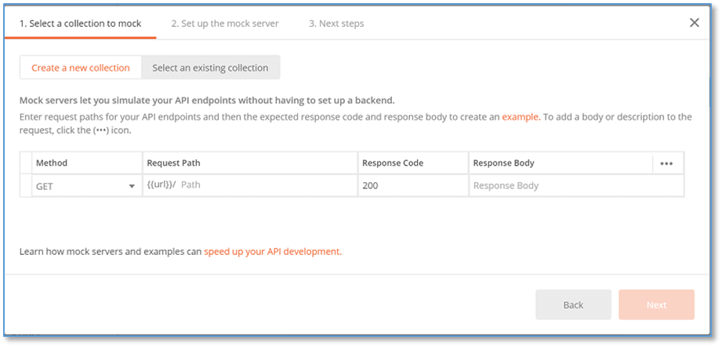

In the above image, we have multiple options.

Here,

* **The method** is request type methods such as GET, POST, etc.
* **Request Path** is the URL of the request for your API.
* **Response Code** is the code in which we want to get in response.
* **Response Body** is the body of the response that you want to show in response.

Fill the column as given below:

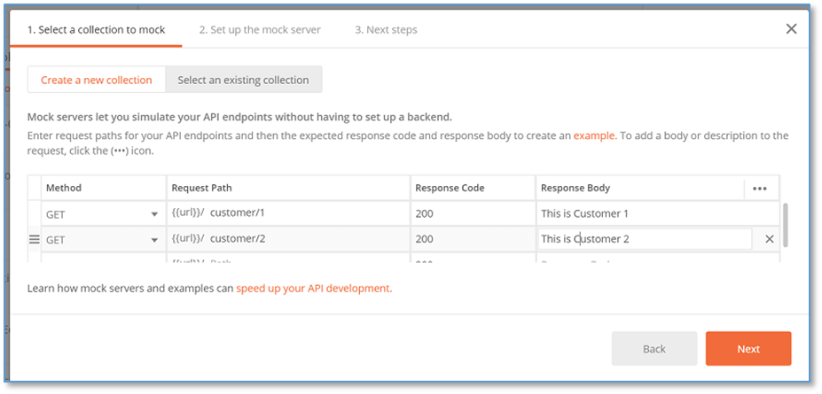

* Click on Next. Now on the next tab, give the name of your mock server. You can give anything as per your choice.

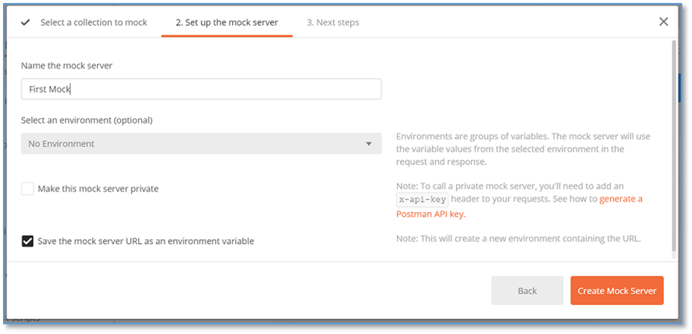

In the above image, you can see one checkbox. If you want to make your mock server private, enable it.

Select the **Create Mock Server** button.

* The next panel is the review panel, which gives you the review that your mock server has been successfully built.

This screen will also display an [URL](https://www.javatpoint.com/url-full-form) through which we can access the mock server.

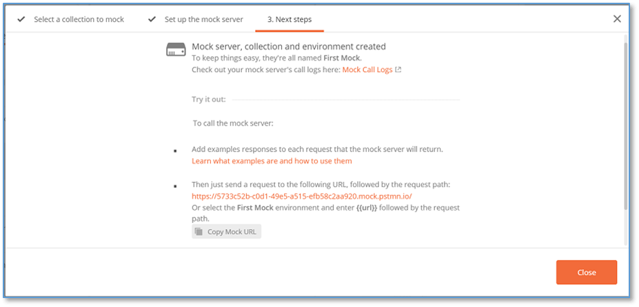

* Click on the Close button to close the panel.

Once you close the panel, a new collection has been generated with the given APIs.

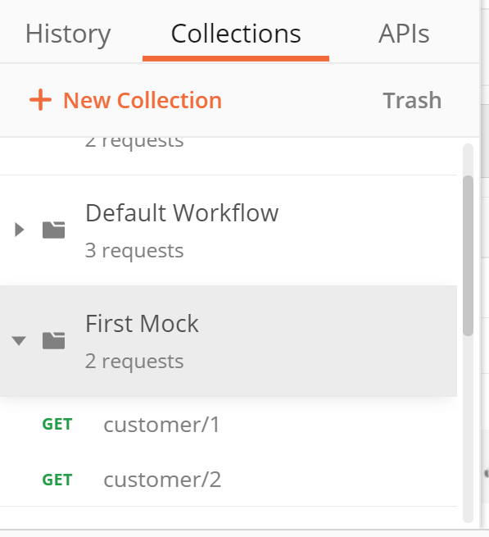

* We can also see a new environment has been created with the same name.

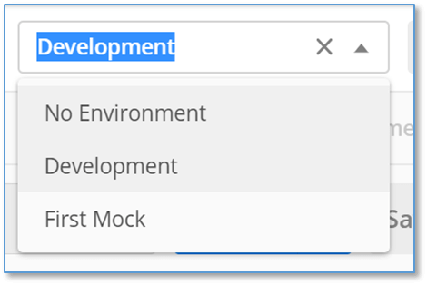

Select this environment variable.

* Now, choose the first request from the collection and see the request url.

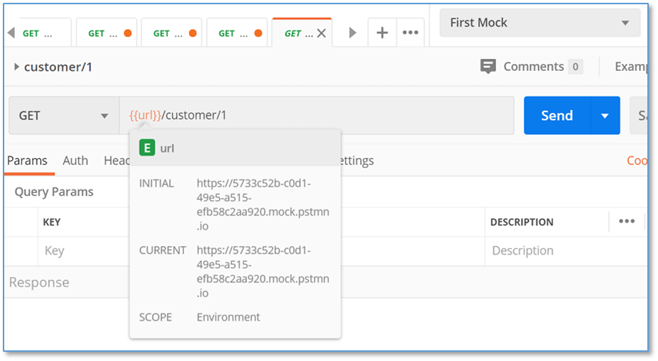

* Click on the send button. Here you can see the response.

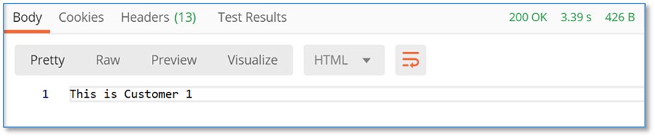

Here, you can see, we got the same response body and the same response code as we have created while setting up the mock server.

# **Get the Response in Mock Server**

Here we will discuss how to get the response in other different formats in [Postman](https://www.javatpoint.com/postman), which is very easy. The most common format is JSON. Let's see how to get the response in [JSON](https://www.javatpoint.com/json-tutorial) format.

* From the top left corner in the Header section of the Postman app, select the **New**



* Select the Mock Server.

AD

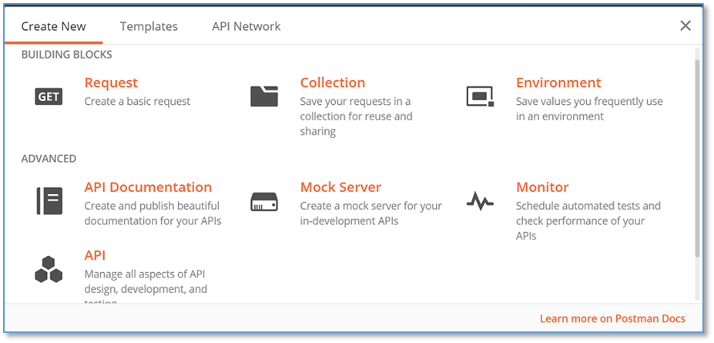

* Once you select the Mock server, a new panel will be opened. Through this panel, we can create a new request.



* In the **Response Body** column, instead of writing plain text, enter the response body in JSON format.

Here, we will write the data about different Employees:

1. {
2. "Employees" [
3. {
4. "Id": "101",
5. "Name": "Nikita Kesharwani",
6. "DOB": "12-12-1992",
7. "Father's Name": "John E. Silverman",
8. "Blood Group": "O+",
9. "Contact Number": "999912345",
10. "Address": "Cartridge World Bradford 212 Manningham Lane BD8 7DT Bradford RShaw Limited T/A Cartridge World",
11. },
12. {
13. "Id": "102",
14. "Name": "Senthil Gonzaleaz",
15. "DOB": "24-06-1989",
16. "Father's Name": "Richard O. Locher",
17. "Blood Group": "AB+",
18. "Contact Number": "+636312749",
19. "Address": "Alina Business & Financial Services 61 High Street SE25 6EF London Alina Business & Financial Services",
20. }
21. ]
22. }

Copy the above JSON in the Response body.

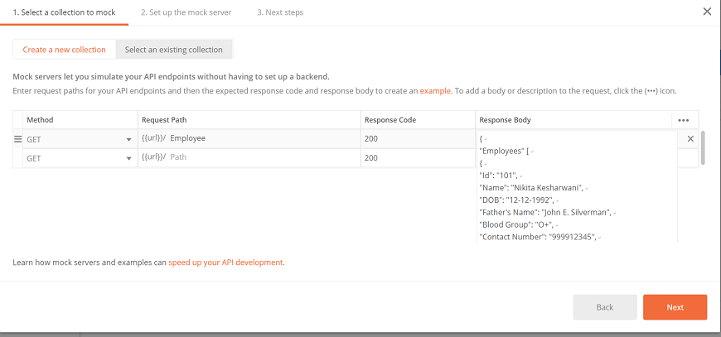

* Press Next. Now in the next panel, give the name of the server as per your choice. I gave 'JSON Response'.

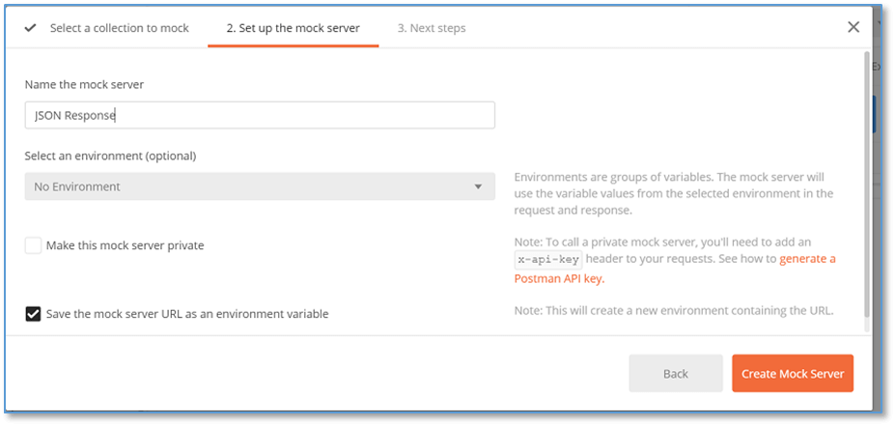

* Select on Create Mock Server button.

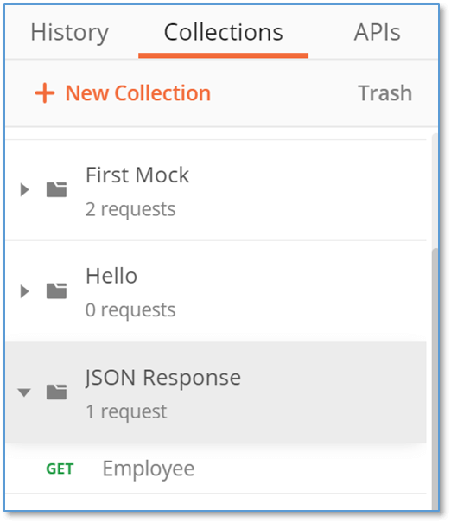

* Select the Employee API and then select the JSON Response environment.

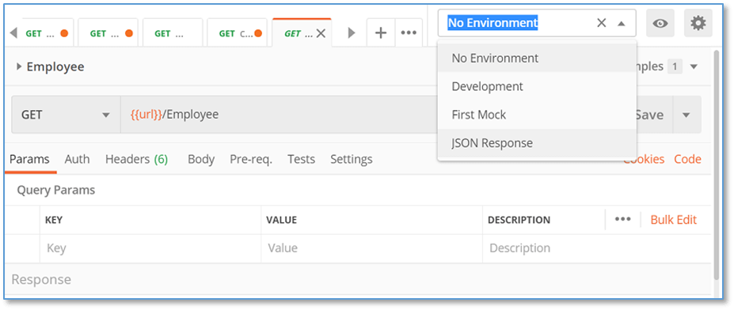

* Press send and see the response.

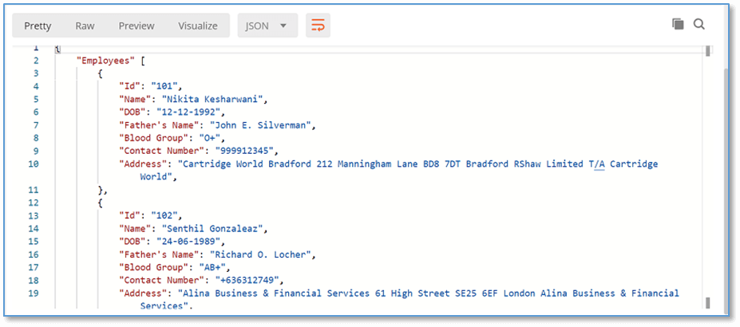

Here, you might get the response in [HTML](https://www.javatpoint.com/html-tutorial) format by default, change the format to JSON from the dropdown, and you will get the response as given above.

Similarly, we can use different formats to get the response in a mock server.

# **Introduction to Postman API**

The endpoints of the Postman API allow you to integrate Postman into your toolchain for development.

In postman API, we can create new collections, update environments, update existing collections, and directly add and run monitors. It helps you to access the stored data programmatically in your postman app.

## **Generating a Postman API Key**

It is necessary to have an applicable [API](https://www.javatpoint.com/api-full-form) key to send the request.

* Go to the following link [web dashboard](https://web.postman.co/workspaces?type=personal).

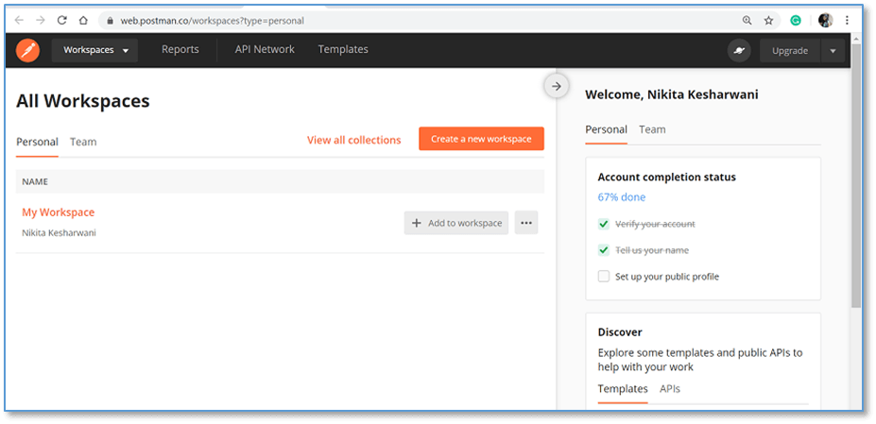

* Choose your workspace.

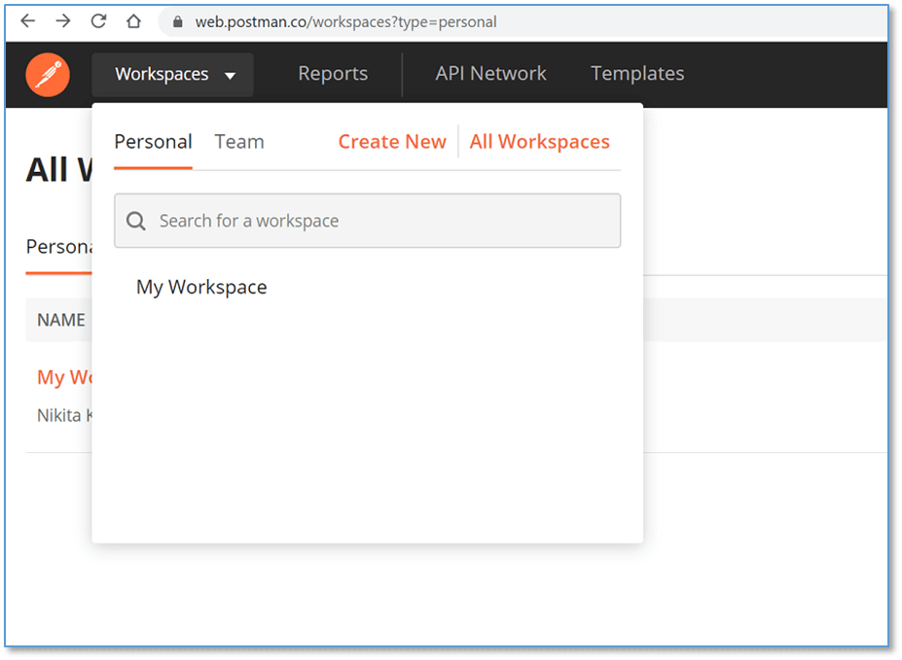

* Select the **Integrations** tab and locate the **Postman API** and then select **View Details**.

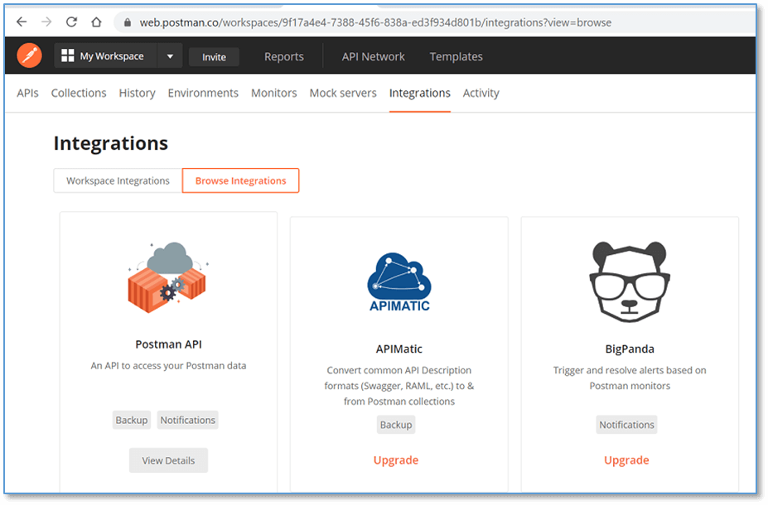

* You will get the **Generate API Key** option if you don't have any keys yet. Select the **Generate API Key**

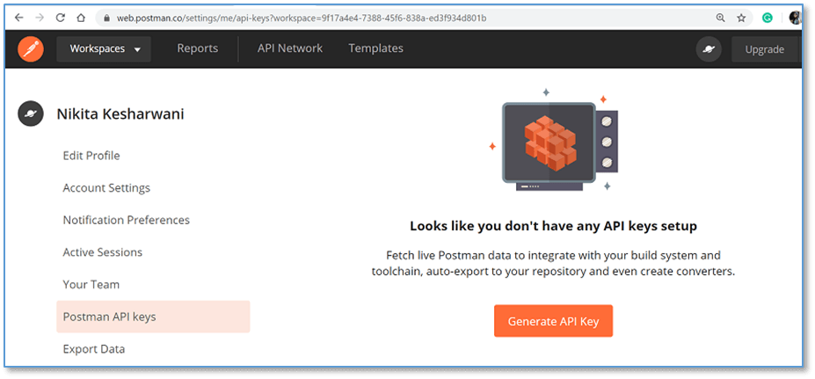

* Enter the name of the key as per your choice and click on Generate API Key. Here I gave 'user-development-key'.

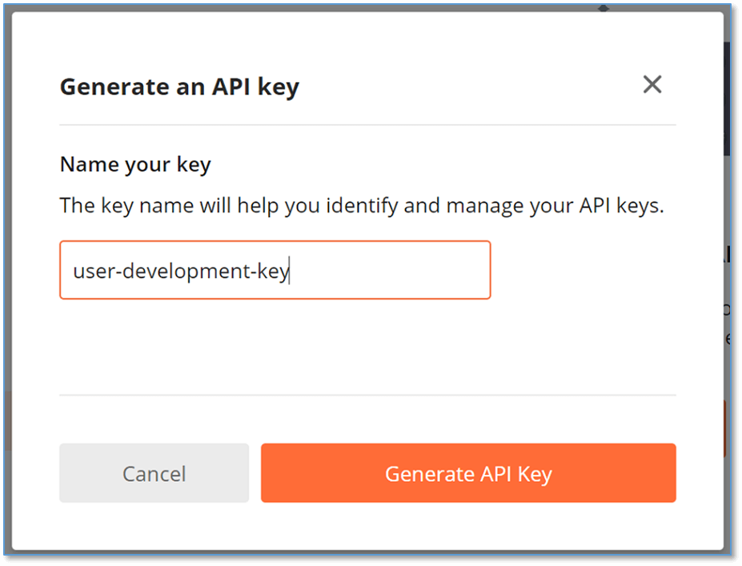

* Don't forget to copy the key. Then click close.

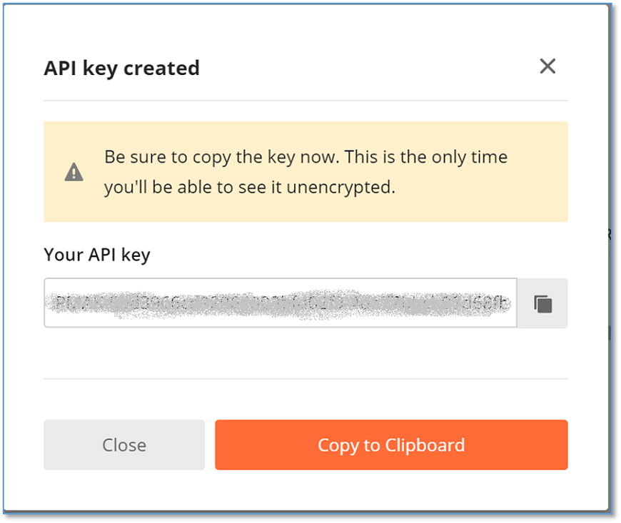

* Your key has been generated. You can now handle the keys within your workspace.

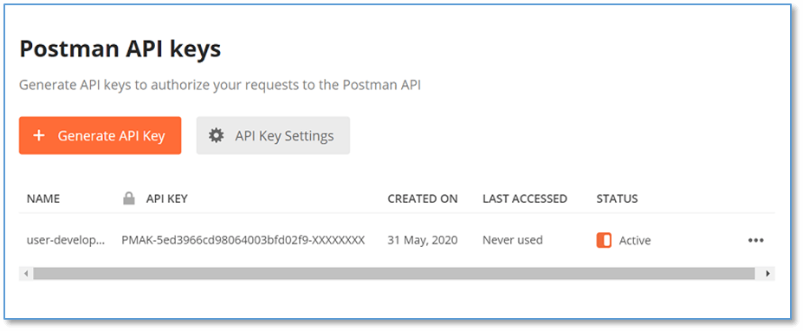

* You can delete and regenerate the key.

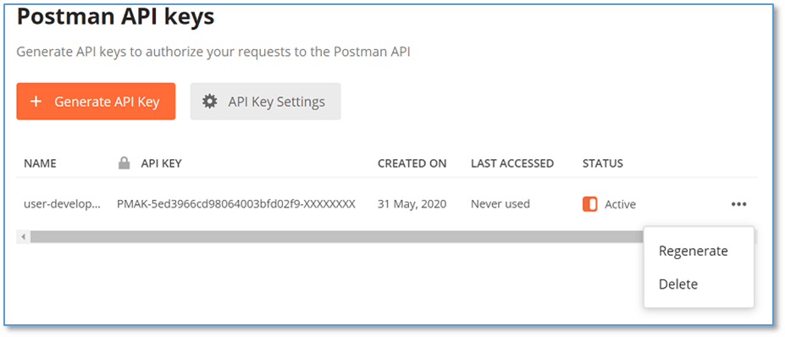

* Select on **API Key Settings** option to set the expiration period of your key.

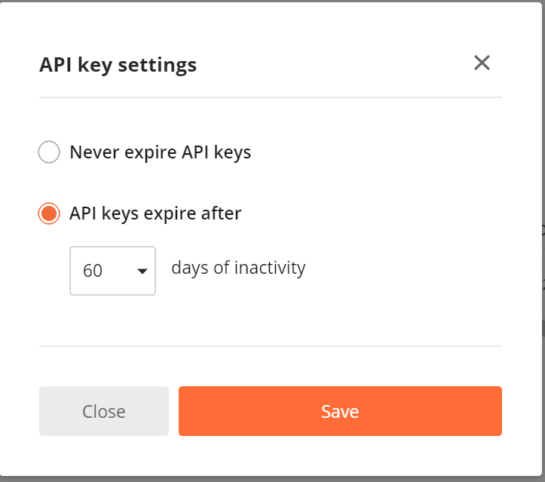

## **Authentication**

By submitting your API Key in the **X-Api-Key** header of any of your created requests, you will need to authenticate your requests to the Postman API.

This API key is used to give access to authorized data.

You can also store your API key in an environment variable with the name **postman-api-key**. The [Postman](https://www.javatpoint.com/postman) API collection can access the API key automatically.

## **Rate Limits**

60 requests per minute are required to access the API with the key.

Each response of an API contains the following set of headers to identify your consumption status.

|  |  |
| --- | --- |
| **Header** | **Description** |
| X-RateLimit-Limit | This header specifies the maximum number of requests the consumer is allowed to submit per minute. |
| X-RateLimit-Remaining | This header specifies the number of requests that are left in the current limit window. |
| X-RateLimit-Reset | This header defines the time at which the current rate limit window resets in UTC epoch seconds. |

# **Continuous Integration**

Continuous Integration is also known as CI. It is a development method that is required several times a day by developers to integrate the code into a shared repository.

Each check-in process involves automating the build and allowing teams to detect problems early. By integrating regularly, we can quickly detect errors, and locate the errors very easily.

To run within your CI environment, let's use collections from [Postman API](https://www.javatpoint.com/postman-api).

Some pre-requisites are:

* It would be best if you had a system set up with Continuous Integration that can execute shell commands and have access to change the same.
* You should have an API key.
* It requires a postman collection that can check your local server, and note the collection UID.

Follow the following steps:

### 1. Install Node

If your CI already have Node installed, you can skip this stage.

Some CI has, by default, installed Node. If your CI has no node, then open this [link](https://nodejs.org/en/download/package-manager/) and follow the steps to install the Node on your CI's platform. Make sure you have [NodeJS](https://www.javatpoint.com/nodejs-tutorial) v4 or above.

### 2. Install Newman

In [Postman](https://www.javatpoint.com/postman), [Newman](https://learning.postman.com/docs/postman/collection-runs/command-line-integration-with-newman/) is a command-line collection runner tool that lets you run a collection on your server or in your local development environment.

To install the Newman use the given command:

1. npm i newman -g;

### 3. Execute Newman

To execute the Newman, use the below command:

1. newman run https://api.getpostman.com/collections/{{collection_uid}}?apikey={{postman-api-key-here}}

The above command is the syntax to run a newman. Change the parameters accordingly.

If you want to modify an environment to the collection, use the given command instead of above command:

1. newman run https://api.getpostman.com/collections/{{collection_uid}}?apikey={{postman-api-key-here}}
2. --environment https://api.getpostman.com/environments/{{environment_uid}}?apikey={{postman-api-key-here}}

# **Branching and Looping**

In Postman, we can also work on branching and looping. We can branch and loop across API requests with the help of setNextRequest() function.

1. postman.setNextRequest("request_name");

This function is used to set the request to be executed next. This function takes one argument, i.e., the name of the request, which will execute next.

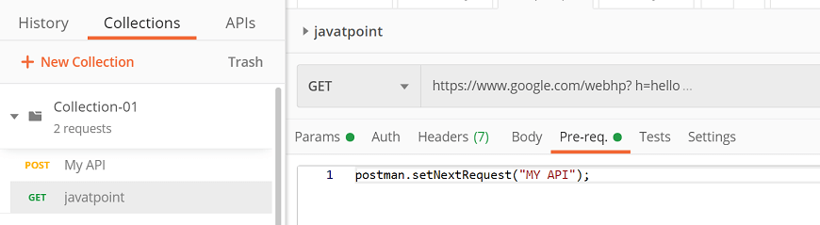

In the above example, "My API" is the name of the request.

Some features of setNextRequest():

* Provide the request name or request ID, and the collection runner will handle the rest.
* We can use the setNextRequest() in the test script as well as in the pre-request script. The last set value takes precedence when you have more than one assignment.
* The collection runner will follow the linear execution settings from default settings and moves to the next request if Postman.setNextRequest() isn't given in a request.

## **Loop Over the Current Request**

If you give the currently running request name in the argument of setNextRequest() function, then Postman will run the same request continuously.

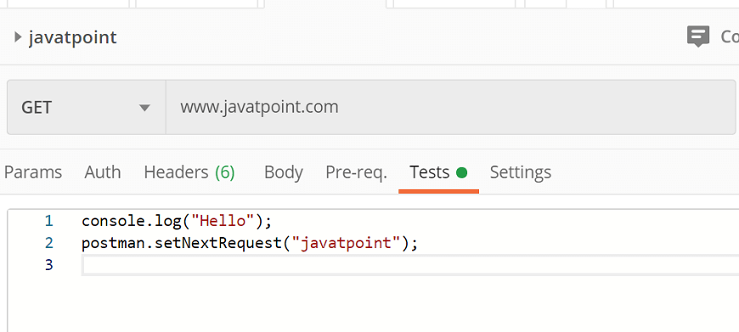

But when you are continuously looping along with the same request, we have to apply some logic on setNextRequest() so that the request won't run endlessly; the collection runner will otherwise have to be force closed.

## **Stop Workflow Execution**

To stop the execution of workflow pass the null argument in setNextRequest() function.

1. postman.setNextRequest(**null**);

# **Forking + Merging: A Conflict Resolution Solution**



[Stacee](https://blog.postman.com/author/stacee/)

January 16, 2019· 3 mins

One of our New Year’s resolutions at Postman is to avoid unnecessary conflict and to help our users do the same, which is why we’re excited to introduce [version control in Postman](https://learning.postman.com/docs/postman/collections/version_control/) 6.7! Similar to branching and merging in version control systems, this new functionality gives Postman teams more control over their collaborative workflows.

Forking a collection creates a linked version of that collection that syncs for teammates who are in the [workspace](https://blog.postman.com/2018/04/07/workspaces-the-biggest-thing-to-hit-postman-this-month/) where the fork was created. This makes it simple for teams to make and test changes without affecting the base collection. After making changes, users can view the diff, verify changes, resolve conflicts, and merge those changes back to the base collection.

This functionality improves collaboration for teams by allowing multiple teammates to work off of different versions of Postman Collections in real time.

**How to Fork a Collection in Postman**

1. Go to your collection and click the ellipsis (**…**)

2. Select “Create a fork”

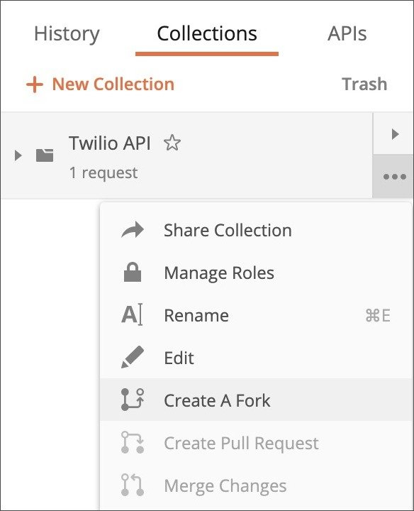Create a new fork in Postman

3. Give your fork a label – this will be used to identify this fork, and distinguish it from the parent

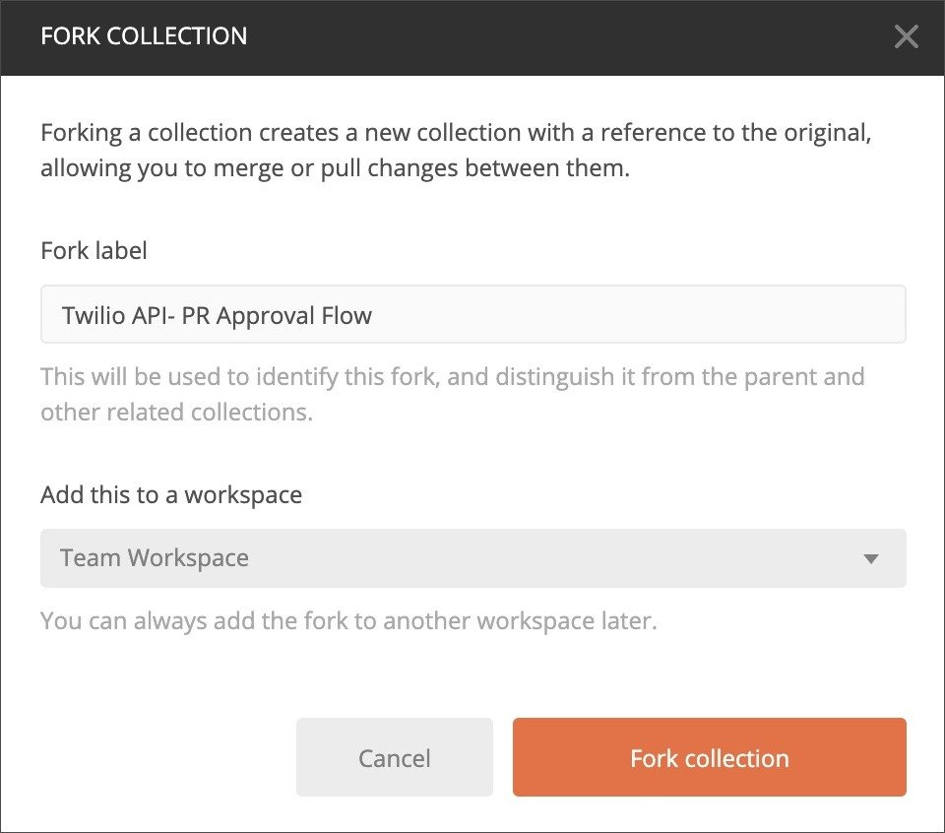Give your fork a label to distinguish it from the parent

4. That’s it! You’ll see your fork added as a new collection with its given label

A forked collection with fork label

### ****How to Merge a Collection and View the Diff in Postman****

1. Go to your collection and click the ellipsis (**…**)

2. Select “Merge changes” and you’ll be taken to your dashboard

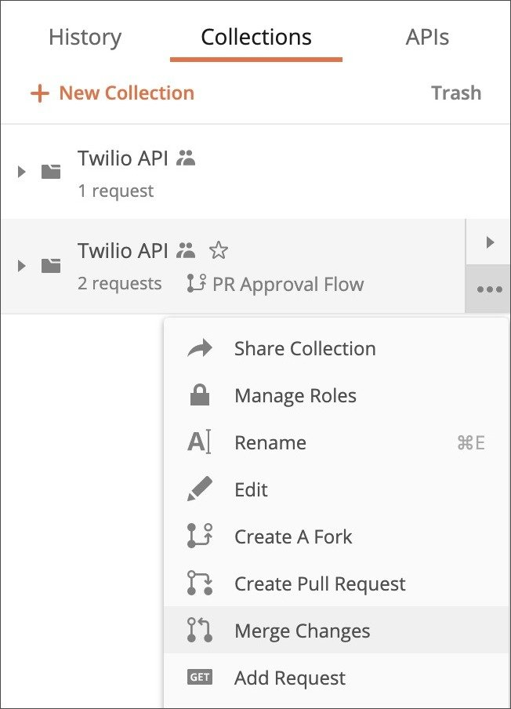Merge changes in Postman

3. Within your dashboard, you can view the diff, select which changes you’d like to use, and resolve any conflicts

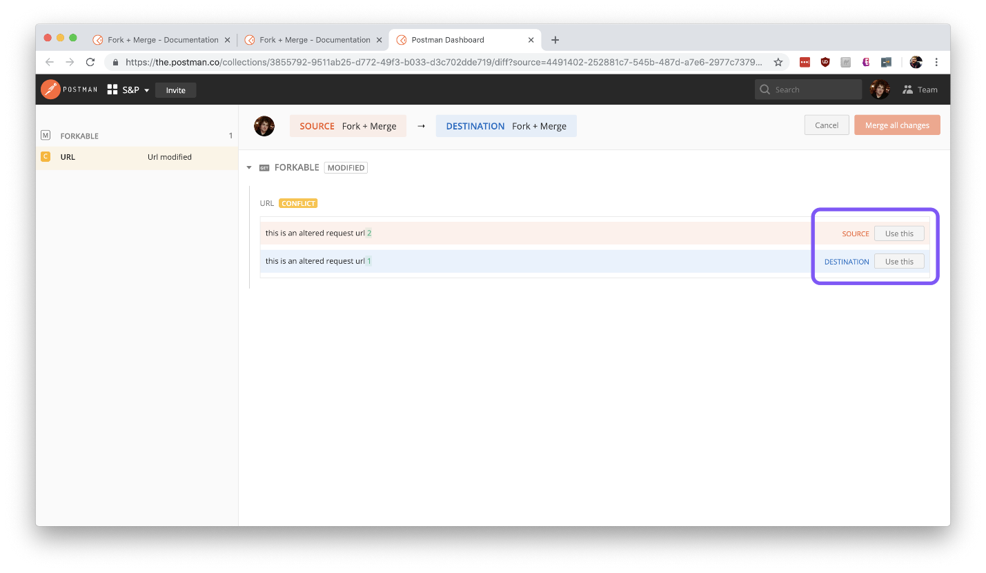View the diff and select changes within the Postman dashboard

4. Once you’ve addressed all changes and conflicts, select “Merge all changes”

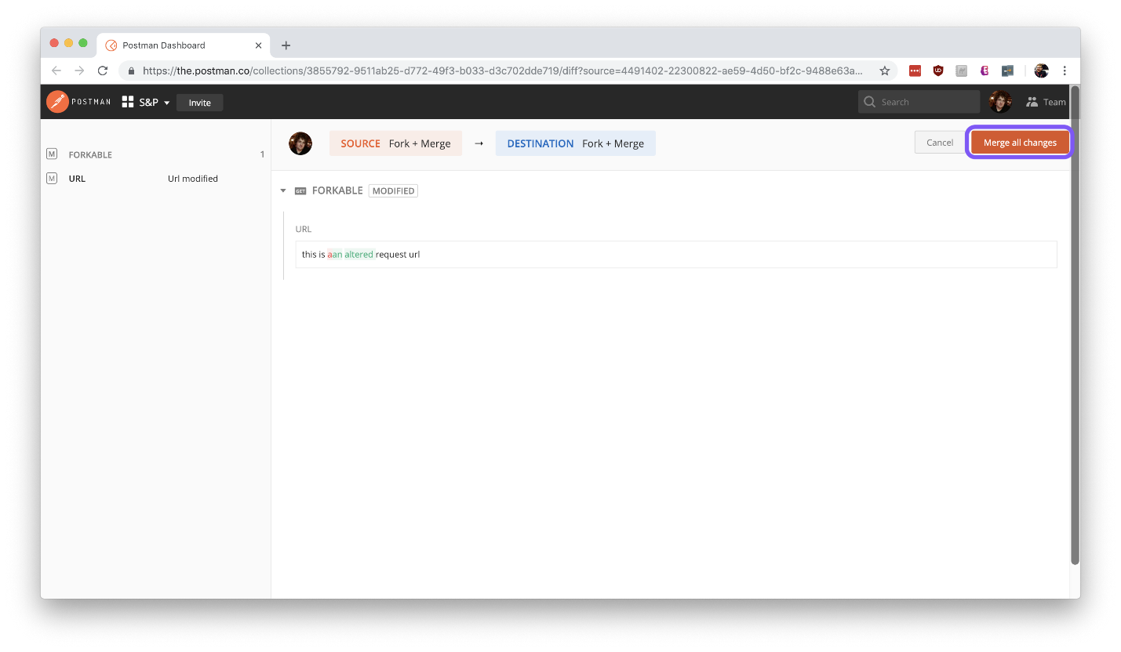Select changes, and view the diff from the Postman dashboard

5. You’ll be prompted on whether you want to:

* update the destination (the original) with the changes,
* update both the source (the fork) and destination with the changes, or
* update the destination and delete the source.

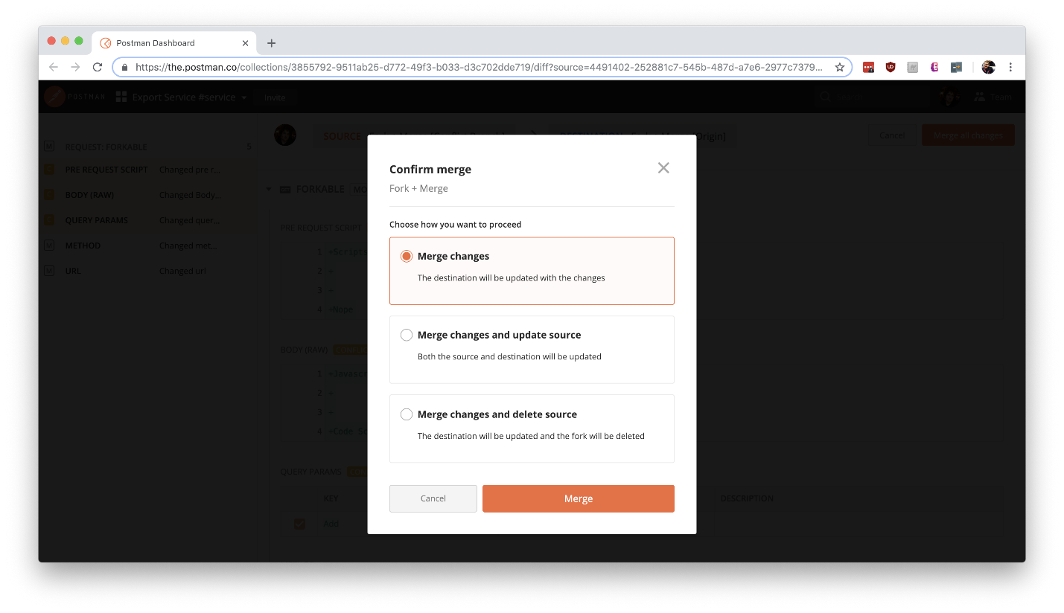Select how you want the destination and source to be updated

^^^^^^^^^^^^^^^^^^^^^^^^^^^^^^^^^^^^^^^^^^^^^^^^^^^^^^^^^^^^^^^^

**Interview questions**

1) What is Postman?

Postman is a free HTTP client-based software application and a collaboration platform for API development. It is mainly used to perform API testing. It is a very popular API client which facilitates developers and provides a platform to design, build, share, test, and document APIs. Postman supports testing of HTTP requests by utilizing GUI (Graphical User Interface), which later we can execute and validate the responses.

The Postman tool also facilitates us to send HTTP/s requests to a service and get their responses. We can ensure that the service is up and running by using this.

2) What was the Postman originally developed?

When the Postman was developed, it was originally a Chrome browser plugin. It extends its solution with the native version for both Mac and Windows.

3) Why do we use Postman?

The Postman tool has become a choice of more than 8 million users. Following are the main reasons for using Postman:

It is free: Postman is free software that we can use for API testing. It is free to download and use for teams of any size.

It is easy to use: Postman is an easy-to-use software tool. We can send HTTP requests of various types (such as GET, POST, PUT, PATCH, etc.). We have to download it, and we can send our first request in minutes. It also gives us the ability to save environments for future use.

Community & Support: It has a huge community forum for customer support and extensive documentation.

It is extensible: Postman facilitates us customizing it according to our needs with the Postman API.

APIs Support: It facilitates us to make any API call (REST, SOAP, or plain HTTP) and easily inspect even the largest responses. It also helps manage the end-to-end lifecycle of the API - starting from design to mocking to testing and finally maintaining the APIs.

Runtime Services: Postman provides Runtime Services that help us manage API collections, environments, work-spaces, and different examples.

Integration: Postman facilitates us to easily integrate test suites into our preferred CI/CD tools and services, such as Jenkins with Newman (command-line collection runner).

4) What is an API?

API is an acronym that stands for "Application Programming Interface". It is a set of routines, protocols, and tools used for building Software applications. API is an interface, so it specifies how one software program should interact with other software programs.

In other words, we can say that API is an Application Programming Interface that acts as an interface between two software applications and allows these two software applications to communicate with each other. API is a collection of software functions that another software program can execute.

5) What are the various authorization methods provided by Postman?

Postman provides the following API request authorization options:

API Key

Oauth 1.0

Oauth 2.0

Bearer Token

Basic auth

Digest auth

Hawk Authentication

AWS Signature

NTLM Authentication

6) What is the use of the collection in Postman?

In Postman, a collection is used to group similar requests. It systematically arranges the requests into folders.

7) What are the various tools used for API Testing?

Following is a list of some tools that are used for API Testing:

Postman

SoapUI

Katalon Studio

Tricentis Tosca

Apigee

Jmeter etc.

8) How can you access the Postman variables?

We can access the Postman variables by using the variable name as:{{variable_name}}

9) What are the different types of API requests supported in Postman?

Following is a list of the different types of API requests supported in Postman:

GET

POST

PUT

PATCH

COPY

DELETE

HEAD

OPTIONS

LINK

UNLINK

PURGE

LOCK

UNLOCK

PROPFIND

VIEW

10) What is an HTTP request? Give an example of an HTTP request.

An HTTP request is a programming request made by the client to a named host located on a server. HTTP works as a communication interface or a request-response protocol between a client and server. The main aim of the HTTP request is to access a resource on the server. To make the HTTP request, the client uses components of a URL (Uniform Resource Locator), which includes the information needed to access the resource.

An example of the HTTP request:

A client (browser) sends an HTTP request to the server; then, the server responds to the client. The response sent by the server contains the status information about the request, and it can also contain the requested content.

11) What are the core components of an HTTP request?

Following are the five core components of an HTTP request:

HTTP methods: It is a set of request methods used to perform needed action for a given resource (GET, PUT, POST, and DELETE).

Uniform Resource Identifier (URI): It is a kind of address that describes the resource.

HTTP Version: It specifies the version of the HTTP. For example HTTP v1.1

Request Headers: It specifies the content type and content length of the request. For example: Content-type: application/ JSON, Content-Length: 511

Payload: It is used to specify the Request Body that includes message content.

12) Why does Postman accept Base64 encoding only?

Postman accepts Base64 encoding only because it transmits the data into the textual form and sends it in an easier form, such as HTML form data. This is also preferred because we can rely on the same 64 characters in any encoding language we want to use.

13) Which type of encoding does Postman accept authorization credentials and why?

Postman accepts authorization credentials in Base64 encoding only. This is inbuilt in Postman, or else you can refer to a third-party website to convert the credentials in base64. The Base64 authorization credentials are generally used because they transmit the data into a textual form and send it in an easier form, such as HTML form data.

14) What are the core components of an HTTP Response?

Following are the four core components of an HTTP Response:

Status/Response Code: The server generates the status or response codes when the client makes a request. For example, 404 means Page Not Found, and 200 means Response is OK.

HTTP Version: It describes the HTTP version. For example: HTTP v1.1, HTTP v1.3 etc.

Response Header: The Response Header includes the information for the HTTP response message. For example, Content-type, Content-length, date, status, and server type.

Response Body: The Response Body contains the client's data requested from the server.

15) What is the meaning of the term environment in Postman?

In Postman, the term environment is a set of key-value pairs. You can create multiple environments in Postman and switch among them quickly by pressing a button. There are 2 types of environment, global and local.

16) Can we have two global scope variables with the same name in Postman?

The global variables are global, so we cannot set duplicate names for them without any environment as it creates confusion for the software. On the other hand, local variables can have the same name but in different environments.

17) Which one is preferred in Postman, a global or local variable?

In Postman, if 2 variables have the same name (one being local, the other global), then the higher priority is of the local variable. The local variable will overwrite the global variable.

18) How can you log variable values in Postman?

In Postman, we can log the variable values in the console by using the following command:

console.log(pm.variables.get("variable_name"));

19) What is the use of Postman monitor?

The Postman monitor is used for running collections. Collections run till the specified time defined by the users. It requires the users to be logged in, and the users share the Monitor reports over an email on a daily or monthly basis.

20) What do you understand by team workspace in Postman?

As we know, a workspace is a collaborative environment for users to develop and test APIs. In the same way, a team workspace is a workspace that is shared by the whole team working on the same collections of requests. Usually, it is time-consuming and hard to share the collections through external drives or other sharing; the team workspace synchronizes and collaborates all the team's work in one place.

21) What is the difference between Query Params and Path Variables?

Query Params or Query Parameters are used for sorting or filtering the resources. On the other hand, Path Variables are used for identifying specific resources.

22) What is the use of Postman Collection runners?

The Postman Collection runner is used to perform Data-driven testing. It runs a group of API requests for multiple iterations with different data sets.

23) What is Basic Auth in Postman?

In Postman, Basic Auth is an authorization technique provided for HTTP user agents like web browsers to enter username and password. After entering the username and password, it gets associated with the request.

24) Can we import local variables in Postman Monitors?

Yes, we can import local variables in Postman Monitors, but it is not allowed to import global variables in Postman Monitors.

25) What are the main limitations of Postman?

Following is the list of key limitations of Postman:

Postman cannot process 1000+ API requests.

In the case of huge projects, it isn't easy to manage the collections and requests.

Postman is not suitable for managing the workspace in the form of code. This is because there would be a lot of code duplication for dynamic API requests.

26) What is a binary form in POST methods? What is its usage?

In POST methods, the binary form is designed to send data easily in a format it is impossible to enter data manually. This is mainly used when sending large files like images, CSV files, etc., in the POST request. The binary representation is one of the easiest representations used for sending complex data with the request.

27) What is the use of Postman cloud when we are working in a company?

The Postman cloud is a common repository of companies to access Postman collections. That is why we use it when we are working in a company. We can save the work instantly in the Postman cloud after logging in. It facilitates the team members to access data/collections from anywhere.

28) What is digest auth in Postman?

The digest auth or digest authorization is one of the authorization techniques provided by Postman. This technique lets the clients send the request first to the API and get responses from the server, including a number that can be used only once a real value and 401 unauthorized responses. After that, the client can send back an encrypted data array with both username and password and the data received from the server earlier. Now, the server uses this data to generate an encrypted data string and compares this with what was sent for authenticating the request.

29) Why is it not suggested to save work in Postman cloud?

It is not suggested and is not preferred to save your work in the Postman cloud as the company's work is not allowed to be leaked and remain confidential. While saving your work on Postman cloud, it may cause a security breach as it requires sign-in. That's why the Postman Cloud is not suggested for saving work, and team workspace is highly preferred.

30) What do you understand by status code 201?

The status code 201 means created when you have successfully created a resource using POST or PUT request. It returns a link to a newly created resource using the location header.

31) What is the procedure to remove local variables?

The local variables are automatically removed once you have executed and completed the tests.

32) What is the procedure to save the responses of API to a file in Postman?

In Postman, there are two ways to save the responses of an API to a file:

First, click on the download button in the response section.

Second, click on the arrow next to the send button. Here, you will see an option to send and download. After clicking on it, you will get a prompt Postman asking for the location of saving the response post successful request execution.

33) What is the meaning of the status code 304?

The status code 304 means NOT MODIFIED. It is used to minimize the network bandwidth usage in conditional GET requests. The response body should be empty. Headers should have a date, and location, etc.

34) What is the use of the 301 status code in Postman?

In Postman, the 301 status code is used to specify that the page has been permanently redirected from one website page to another. It tells the search engine that the old page is outdated, and the search engine has to index the new page URL.

35) What is the method to organize requests in Postman?

We can organize requests in Postman with the Collections.

36) What are the various variable scopes provided by Postman?

Following is a list of several variable scopes provided by Postman:

Global Variables: Global variables allow data access between different collections, requests, and scripts. They are available throughout the workspace.

Local Variables: Local variables are the temporary variables that can be accessed only within the scope of requests scripts. Depending on the requirements, these variables are either scoped to a single request or single collection. These variables are not available once the script execution is completed.

Environment Variables: The Environment variables allow us to tailor the requests about different development environments such as local testing, stage testing, or prod testing.

Collection Variables: The Collection variables are independent of the environment and scoped to be available for all the requests present within the collection.

Data Variables: The Data variables come from external JSON or CSV files and define the datasets required to run the collection in Collection Runner or Newman.

37) What is the difference between the form data and x-www-form-urlencoded?

The key difference between the form data and x-www-form-urlencoded is that the URL will be prearranged when sent through x-www-form-urlencoded.

38) In which conditions should we use global, collection, and local variables?

Global variables are the general-purpose variables. They are used while passing data to other requests and are ideal for quick results and prototyping.

Collection variables are generally used for storing some constants that do not change during the execution of the collection. These variables are used for constants that do not change during the execution and URLs / authentication credentials if only one environment exists.

Local variables are the temporary variables and are only available within the request that has set them or when using Newman/Collection runner during the script execution. These variables are used whenever we have to override all other variable scopes.

39) How can we access the history of requests in Postman?

In Postman, we can access the history of requests in the History tab provided on the Postman application. When we sign into the Postman account, the history will be synced across the devices where you are logged in. After clicking on any of the requests present in the History tab, the view will open the request that we saved while working on it earlier. History also contains the collection runs that were executed as summarized versions.

When you click on the "View More option" on the request, you will see options to save, document, monitor, delete or mock the request. You can also select multiple requests by using Command or Control button and then clicking on the request.

40) How can we stop executing requests or stop the collection run?

We can stop executing requests or stop the collection run by using the following command:

postman.setNextRequest(null);

41) Is it possible to reuse the authentication token for multiple requests?

Yes, it is possible to reuse the authentication token for multiple requests. We can achieve it by creating a collection and adding all the requests having the same authentication token to that collection and then assigning the auth token to the same collection. We can apply it to the individual requests by selecting the "Inherit auth from parent" option in the Authorization tab.

42) Where are the query parameters stored in a GET request in Postman?

In the GET request, the query parameters are stored in the URL in Postman.

43) What is executed first in a collection run?

The pre-request scripts at the compilation level are executed first in a collection run.

44) How can we access a Postman variable?

We can access a Postman variable by entering the variable name as {{var}}.

45) Which tool can be used to run Postman collections in Jenkins?

We can use the Newman tool to run Postman collections in Jenkins.

46) What are the most commonly seen status codes in Postman?

Following is the list of most commonly seen status codes in Postman:

200 (OK): Status code 200 specifies that the request was correct.

201 (Created): Status code 201 specifies that the value wrapped with the request has been created in the database. Here, it is obvious that the request was correct.

204 (No Content): Status code 204 specifies that the request was correct and received, but there is no content to send. It means there is no response to send to the client by the server.

400 (Bad Request): Status code 400 specifies a bad request. A bad request means that the syntax of the request was incorrect. It appears when we have sent the wrong parameters along with the request URL or in the request's body.

401 (Unauthorized request): Status code 401 specifies an unauthorized request. An unauthorized request is a request for which you are not authorized. This status code appears when we are not authorized to access the server or enter the wrong credentials.

404 (Not Found): Status code 404 specifies that the server was connected, but it could not find what was requested. It simply means "request not found". This status code normally appears when we request a web page not available on the server.

47) What is Scratch Pad?

Postman provides a space known as Scratch Pad. The Scratch Pad facilitates us to work without being connected to Postman servers and also provides the flexibility to utilize some of the features of Postman offline. These features include collection creation, creating requests, and the ability to send requests. The Scratch Pads are stored locally, and once logged in; the work is saved into the workspace.

48) What are the different Request Method types in Postman?

The different Request Method types in Postman are as follows:

Get

Post

Put

Delete

Patch

Head

Delete

49) How can you iterate a request 100 times in Postman?

We can iterate a request 100 times in Postman using Collection Runner.

50) What are some examples of the JS libraries available in Postman?

Some examples of the JS libraries available in Postman are Lodash, Moment, GUID, etc.

51) What is the full form of GUID? Where is it used?

GUID is an acronym that stands for Global Unique Identifier. It is a set of hexadecimal digits separated by hyphens and solves the purpose of uniqueness.

In Postman, it is used to generate and send a random value to APIs.

Example:

{

"id": "{{$guid}}",

}

52) Which programming language is used for Postman tests?

JavaScript is used for Postman tests.

53) How can you generate random numbers of a given range in Postman?

In Postman, we can generate random numbers of a given range using some script. Suppose you want to generate numbers between the range of 1 to N, then use the following pre-request script:

pm.globals.set('randomNumber', Math.floor(Math.random()* N));

Now, use this variable in the URL as {{randomNumber}}

54) How can we view request logs and response logs in Postman?

We can view request logs and response logs in Postman through the Postman Console window.

55) What is the binary form in the Post method in Postman?

In Postman, the binary form is designed to send the information in a specific format that cannot be entered manually. For example, images, files, etc. Everything in a computer is converted to binary.

56) How can you organize requests in Postman?

In Postman, we can use Collections to organize requests.

57) Which method is preferred to write the tests?/ JavaScript or Functional?

The functional method is advised and recommended while writing tests in Postman. Although we can use JavaScript methods, there has been no notice of ending the support for the JavaScript method.

**Naveen Automation Labs**

API are used when two systems are interactingwith each other.

<https://www.youtube.com/watch?v=LUbBkiIhrE4&list=PLFGoYjJG_fqp891lruz5fCRPWsDtEXJky>

WebServices : (MakemyTrip.com)

Api – Web Services 🡺HTTP/network

**Request payload**: In APIs, the payload is the data contained within a request.

Response JSON: Response to a API in JSON format

Response XML: Response to a API in XML format

Authentication : Session/Token ID

Username/ password

Request -JSON/XML

HTTP method – CRUD

SOAP: Simple Object Access Protoco : is a protocoll

Rest : REpresentational State Transfer : is architectural style

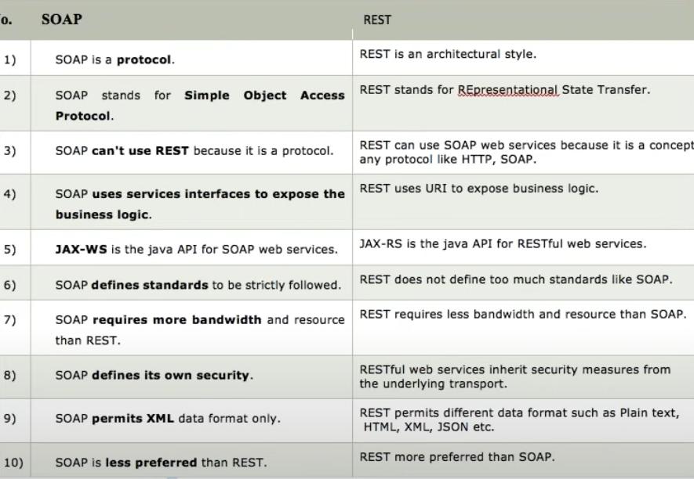

**Rest webservices Automation**

What is Rest Client

HTTP Request = URI +Header + payload (JSON/XML)

HTTP Response = Status + Response payload +String message (successful)

Create Account 🡺POST call 🡺 used to create a new entity 🡺Header +payload

Get an account 🡺GET call 🡺 URI + Path parameter + Query parameter + header

Update account 🡺PUT call 🡺create+ update

Delete Account 🡺DELETE call 🡺

URI = Path parameter +query parameter

HTTP status response codes

<https://developer.mozilla.org/en-US/docs/Web/HTTP/Status>

Status Response code 🡺

200= ok

201 = Created successfully

400 = Bad request

401 = Authentication error

404 = Not found

500 = Server internal error

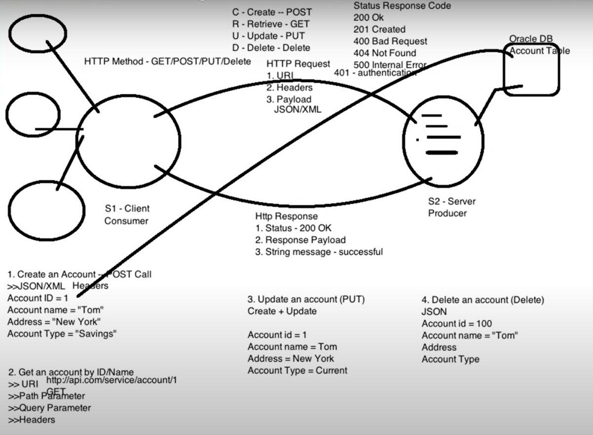

What is postman?

It is a Rest client.

SOAP UI, Advanced Rest Client, JMeter , browser

URL (Endpoint URL + API/Service URL) = URI

Query Paramenter is defined by ?

Path parameter is defined by /

What Is Swagger?

Swagger allows you to describe the structure of your APIs so that machines can read them. The ability of APIs to describe their own structure is the root of all awesomeness in Swagger.

<https://fakerestapi.azurewebsites.net/index.html>

Swagger: Api documentation

Step1

Create maven project

Add dependancies

http client

http core

JSON In Java

TestNG

CloseableHttpResponse : is a Interface

|  |
| --- |
| HttpClients.createDefault() : Create one client connection and returns CloseableHTTPclient object.  **CloseableHttpClient** is the base class of the **httpclient** library, the one all implementations use. |
| HttpGet() : is a class |
| httpClient.execute(httpGet); executes a request or hits the api and returns closeable HTTPResponse |
| httpResponse.getEntity() : Obtains the message entity of this response, if any.The entity is provided by calling setEntity.Returns:the response entity, or null if there is none |
| EntityUtils.toString(httpResponse.getEntity(), "UTF-8" );  EntitiUtils : Static helpers for dealing with [HttpEntity](eclipse-javadoc:%E2%98%82=restapi/C:%5C/Users%5C/TISHAN1KA%5C/.m2%5C/repository%5C/org%5C/apache%5C/httpcomponents%5C/httpcore%5C/4.4.7%5C/httpcore-4.4.7.jar=/maven.pomderived=/true=/=/maven.pomderived=/true=/=/maven.groupId=/org.apache.httpcomponents=/=/maven.artifactId=/httpcore=/=/maven.version=/4.4.7=/=/maven.scope=/compile=/%3Corg.apache.http.util(EntityUtils.class%E2%98%83EntityUtils%E2%98%82HttpEntity)s. |
| JSON obj = new JSONObject(responseString)  Converts Response to JSON Object |
|  |
|  |
|  |
|  |
|  |
|  |
|  |
|  |
|  |

Add dependancy in pom.xml :

Jackson Databind

**HTTP Client**

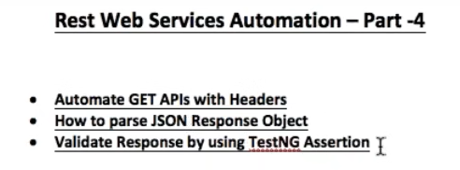

RestClient.java

|  |
| --- |
| //get method without headers  public CloseableHttpResponse get(String url) throws ClientProtocolException, IOException {  CloseableHttpClient httpClient = HttpClients.createDefault();  HttpGet httpGet = new HttpGet(url); // http get request  CloseableHttpResponse closeableHttpResponse = httpClient.execute(httpGet); // hit the URL  return closeableHttpResponse;  } |

|  |
| --- |
| package com.qa.tests;  import java.io.File;  import java.io.IOException;  import java.util.HashMap;  import org.apache.http.Header;  import org.apache.http.client.ClientProtocolException;  import org.apache.http.client.methods.CloseableHttpResponse;  import org.apache.http.util.EntityUtils;  import org.json.JSONObject;  import org.testng.Assert;  //import org.junit.Assert;  import org.testng.annotations.BeforeMethod;  import org.testng.annotations.Test;  import com.fasterxml.jackson.core.JsonGenerationException;  import com.fasterxml.jackson.databind.JsonMappingException;  import com.fasterxml.jackson.databind.ObjectMapper;  import com.qa.base.TestBase;  import com.qa.client.RestClient;  import com.qa.data.Users;  public class PostApiTest extends TestBase {  TestBase testBase ;  String mainUrl ;  String apiUrl ;  String url ;  RestClient restClient;  **PostAPITest.java**  CloseableHttpResponse closeableHttpResponse;    @BeforeMethod  public void setUp() throws ClientProtocolException, IOException {  System.out.println("GetAPITest ==> @BeforeMethod ==> setUp");  testBase = new TestBase();  mainUrl = prop.getProperty("url");  apiUrl =prop.getProperty("serviceurl");  url = mainUrl + apiUrl;  }    @Test  public void postAPITest() throws JsonGenerationException, JsonMappingException, IOException {  restClient= new RestClient();  HashMap <String, String> headerMap = new HashMap<String , String>();  headerMap.put("Content-Type", "application/json");    ObjectMapper mapper = new ObjectMapper();  Users users= new Users("morpheus" , "leader");    String filePath1 = "C:\\Users\\TISHAN1KA\\eclipse-workspace\\restapi\\src\\main\\java\\com\\qa\\data\\users.json";    //System.out.println(filePath1);    //This is marshalling ==> java to Json  //Object to json File  mapper.writeValue(new File(filePath1), users);    //Object to json String  String userJsonString = mapper.writeValueAsString(users);  //System.out.println("userJsonString = " + userJsonString);  closeableHttpResponse = restClient.postUser(url, userJsonString, headerMap);      //get Status code  int statusCode = closeableHttpResponse.getStatusLine().getStatusCode();  Assert.assertEquals( statusCode , testBase.Response_Code_201);    //Json String  String responseString = EntityUtils.toString(closeableHttpResponse.getEntity(), "UTF-8");  System.out.println("responseString = " + responseString);    JSONObject responseJson = new JSONObject(responseString);  System.out.println("responseJson = " + responseJson);    //This is unmarshalling ==>json to java  //json to java object  Users userResObj = mapper.readValue(responseString, Users.class); //actual user object  System.out.println(userResObj);    Assert.assertTrue(users.getName().equals(userResObj.getName()));  Assert.assertTrue(users.getJob().equals(userResObj.getJob()) );  System.out.println(userResObj.getId());  System.out.println(userResObj.getCreatedAt());  }    } |

|  |
| --- |
| **TestUtil.java**  package com.qa.util;  import org.json.JSONArray;  import org.json.JSONObject;  public class TestUtil {    public static JSONObject responsejson;      public static String getValueByJPath(JSONObject responsejson, String jpath){  Object obj = responsejson;    for(String s : jpath.split("/"))  if(!s.isEmpty())  if(!(s.contains("[") || s.contains("]")))  obj = ((JSONObject) obj).get(s);  else if(s.contains("[") || s.contains("]"))  obj = ((JSONArray) ((JSONObject) obj).get(s.split("\\[")[0])).get(Integer.parseInt(s.split("\\[")[1].replace("]", "")));  return obj.toString();  }  } |

HTTPPost

Create client

Create request

Add payload

Add headers

Execute the request

Create post call

Call API

Perform marshalling

Call the postAPI

Validate response

Steps

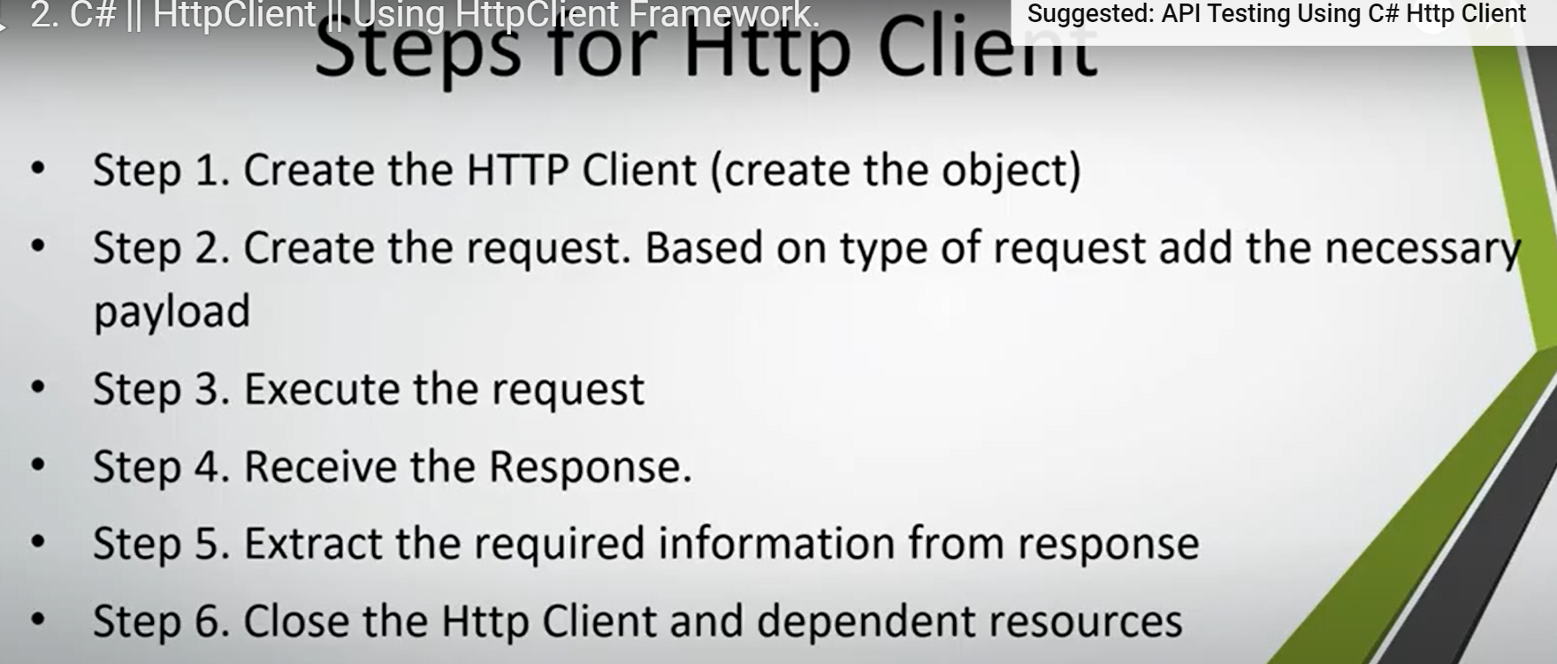

Get Method

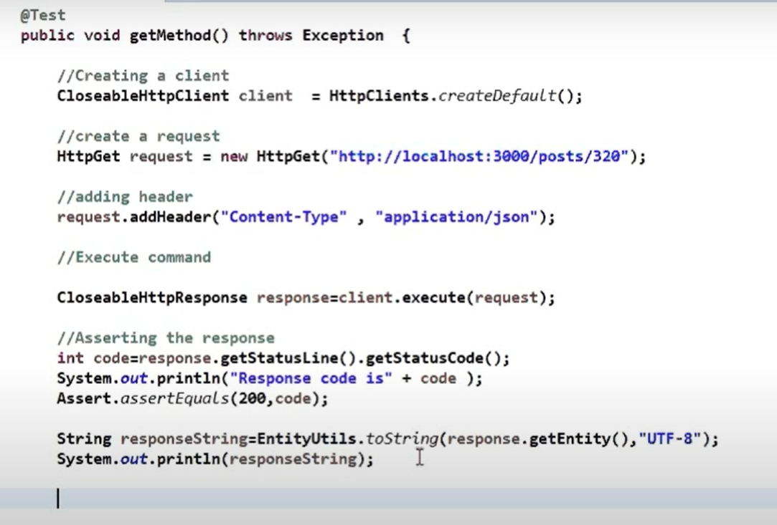

Post Method

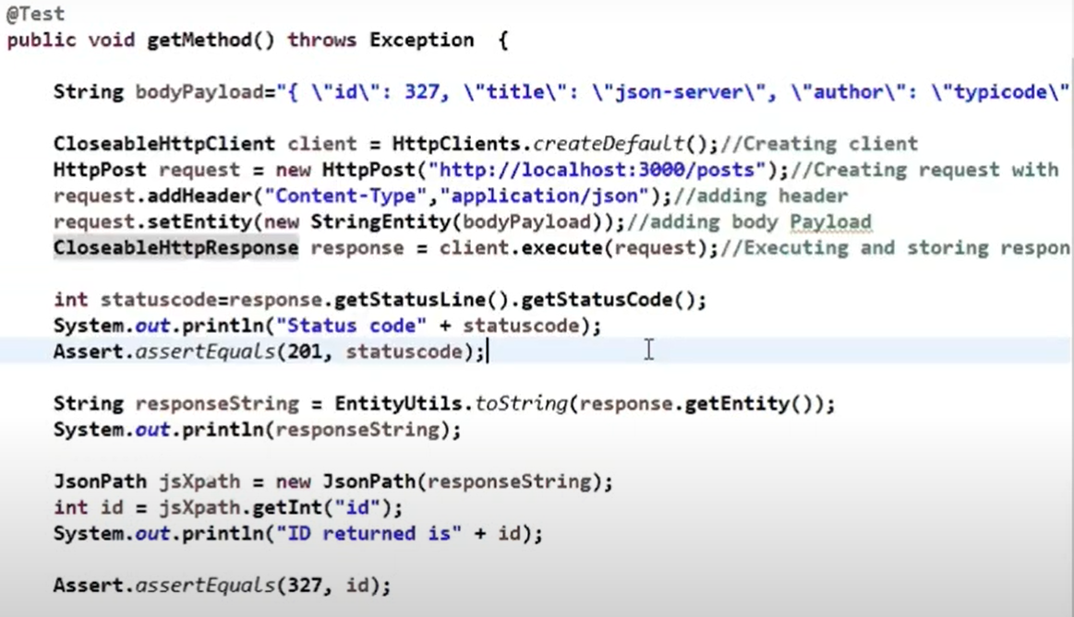

*Whenever there is a pay load create a equivalent java class (POJO class)

============================

POJO class: Plain Old Java Object

Marshalling:

Marshalling is the process of writing Java objects to XML file. Unmarshalling is the process of converting XML content to Java objects. Create Java Application client (main ())

Marshalling is a technique that can be easily understood and utilized efficiently. IT is the process of converting a POJO(Plain Old Java Object) in memory into a format that can be written to disk or send via network, usually in text formats like xml or json. The reverse of this technique is called unmarshalling.

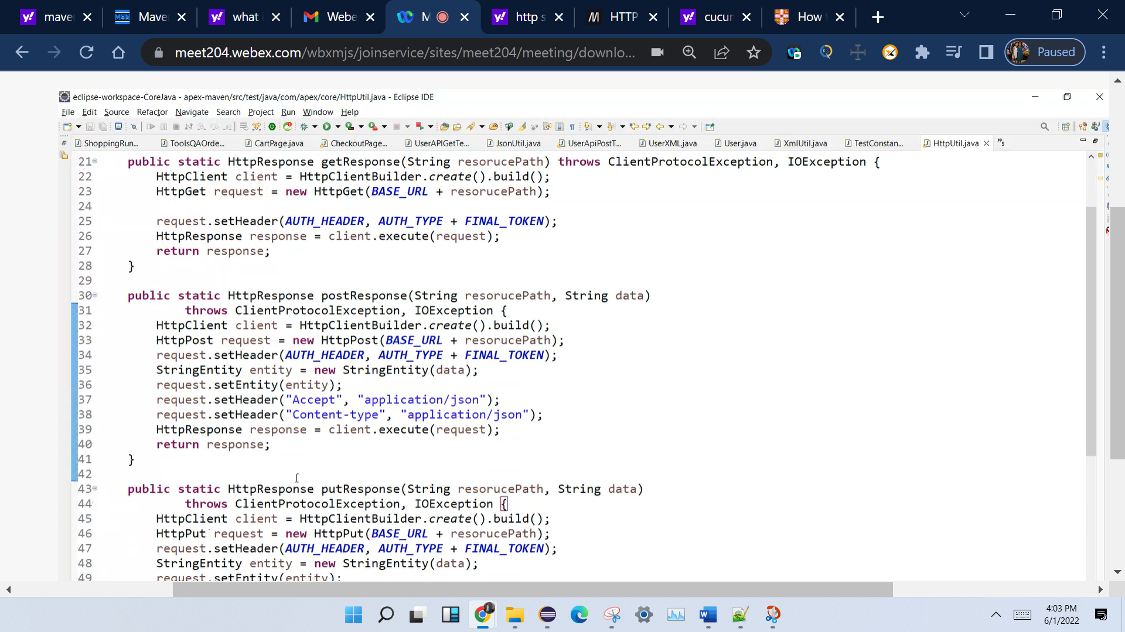

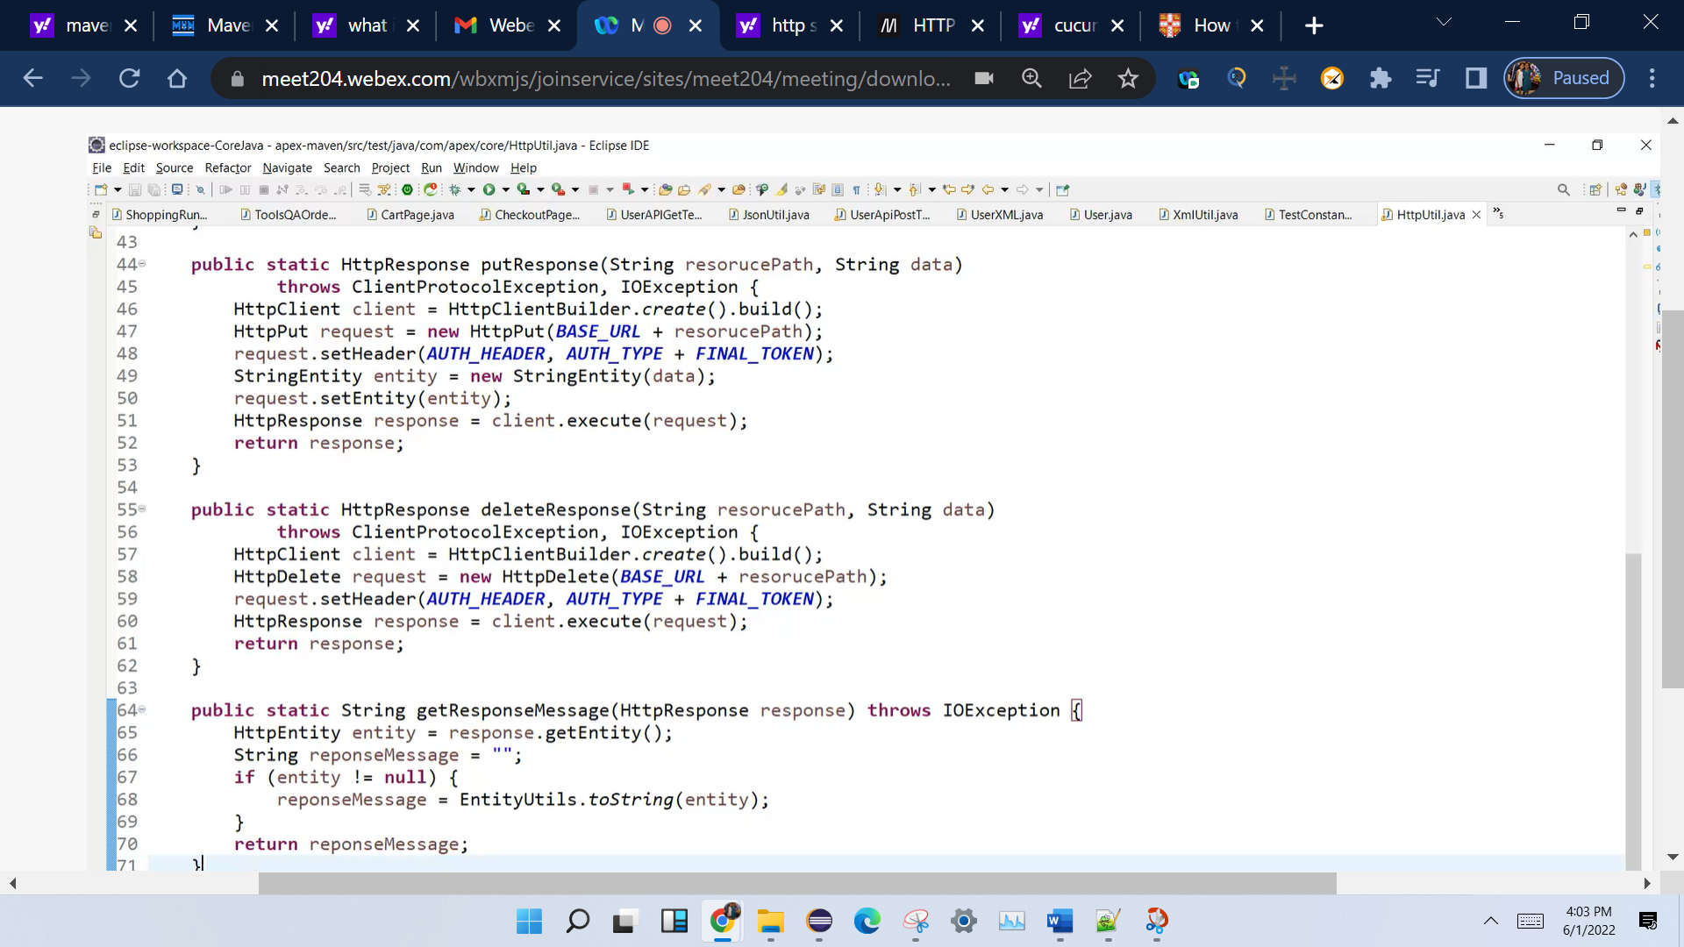

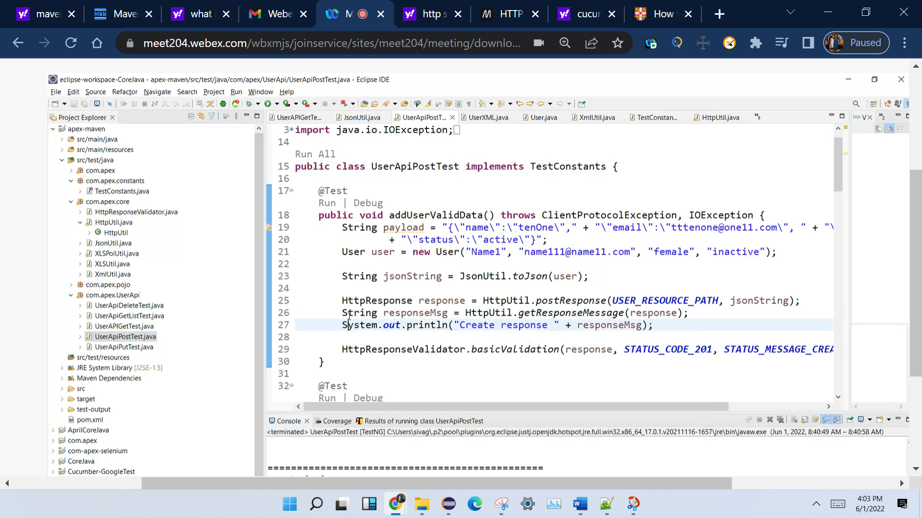

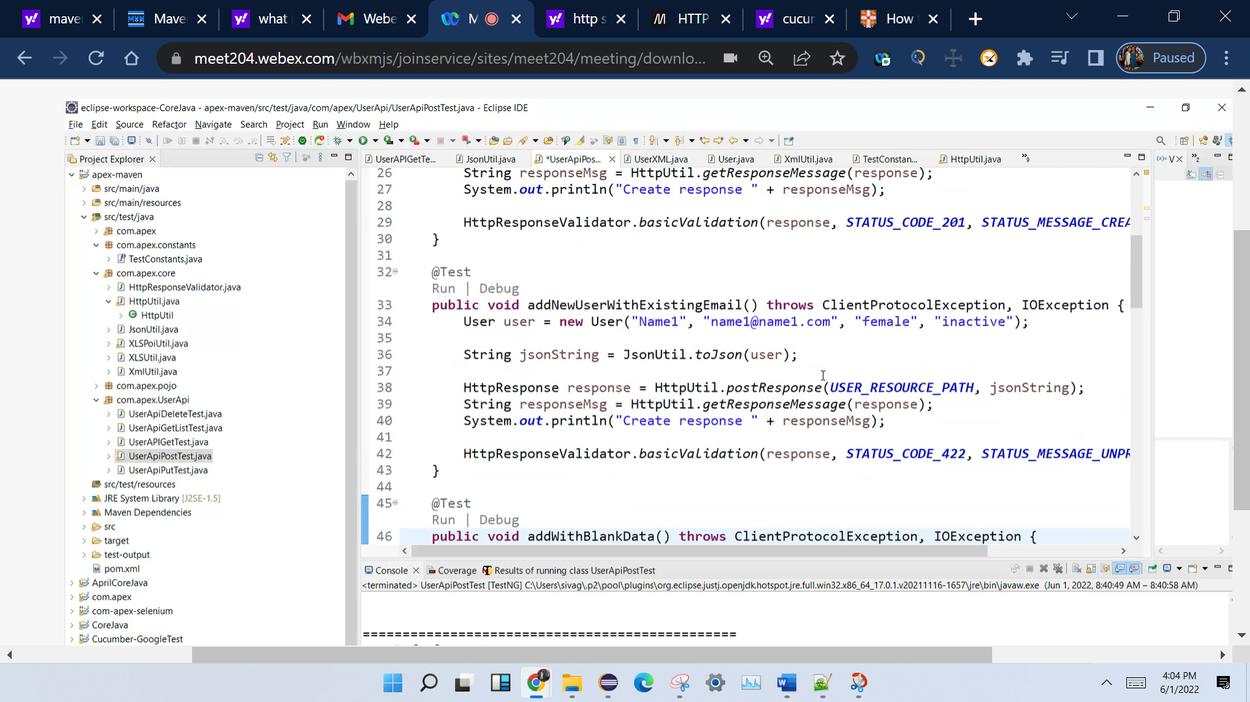

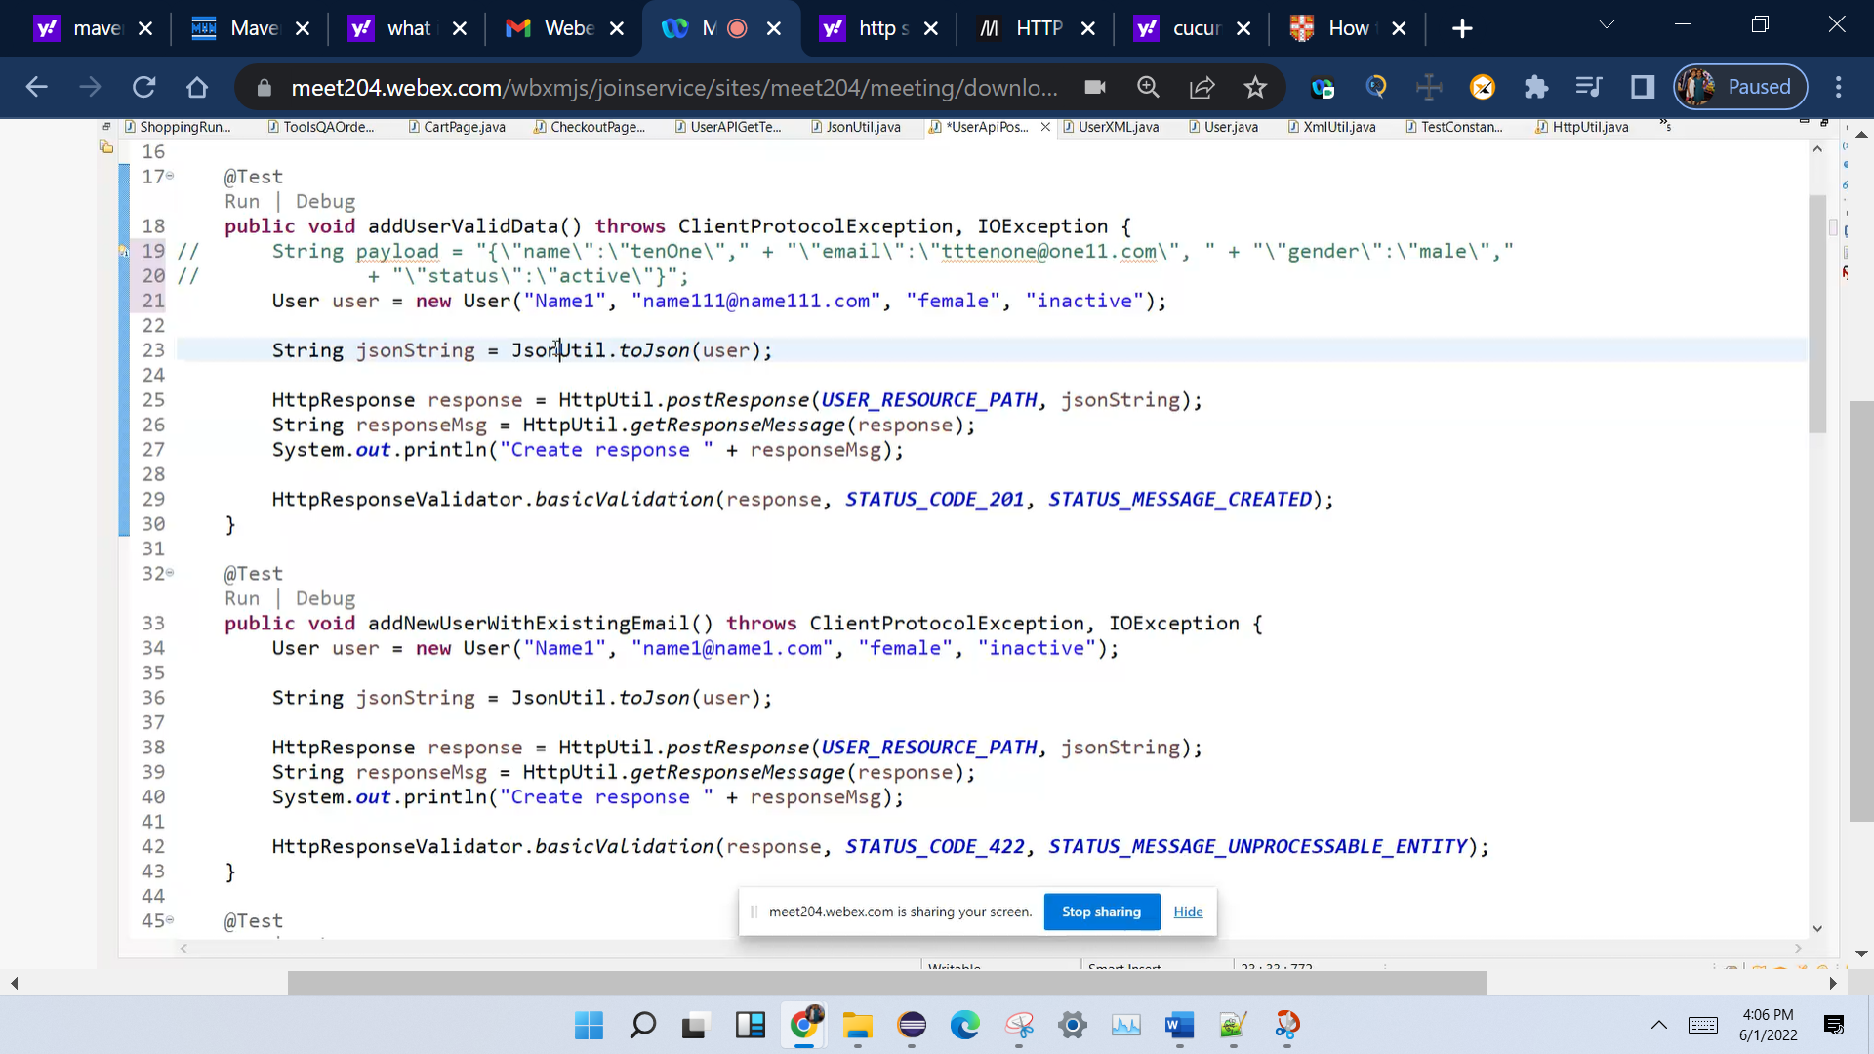

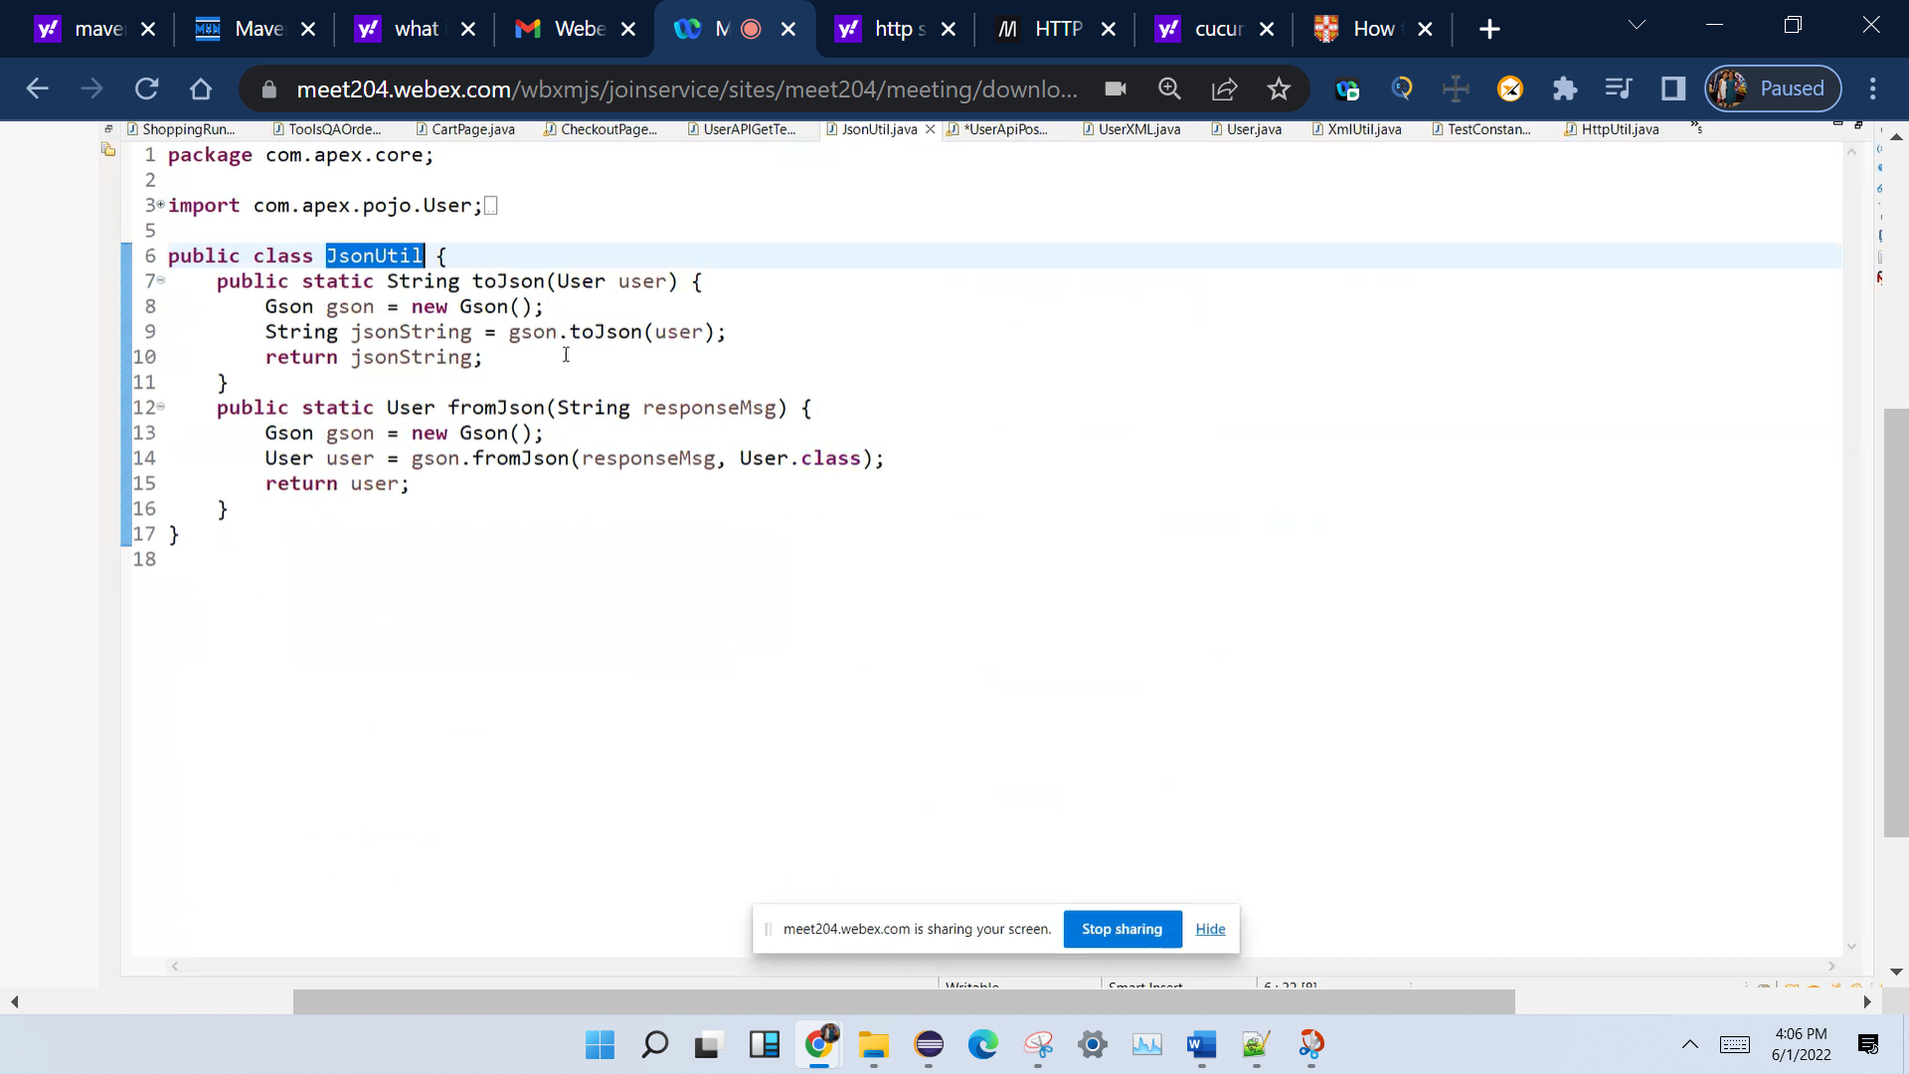

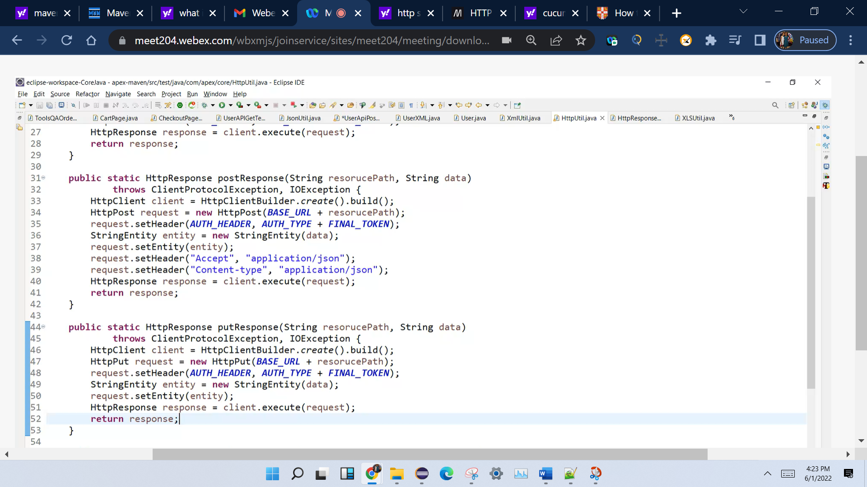

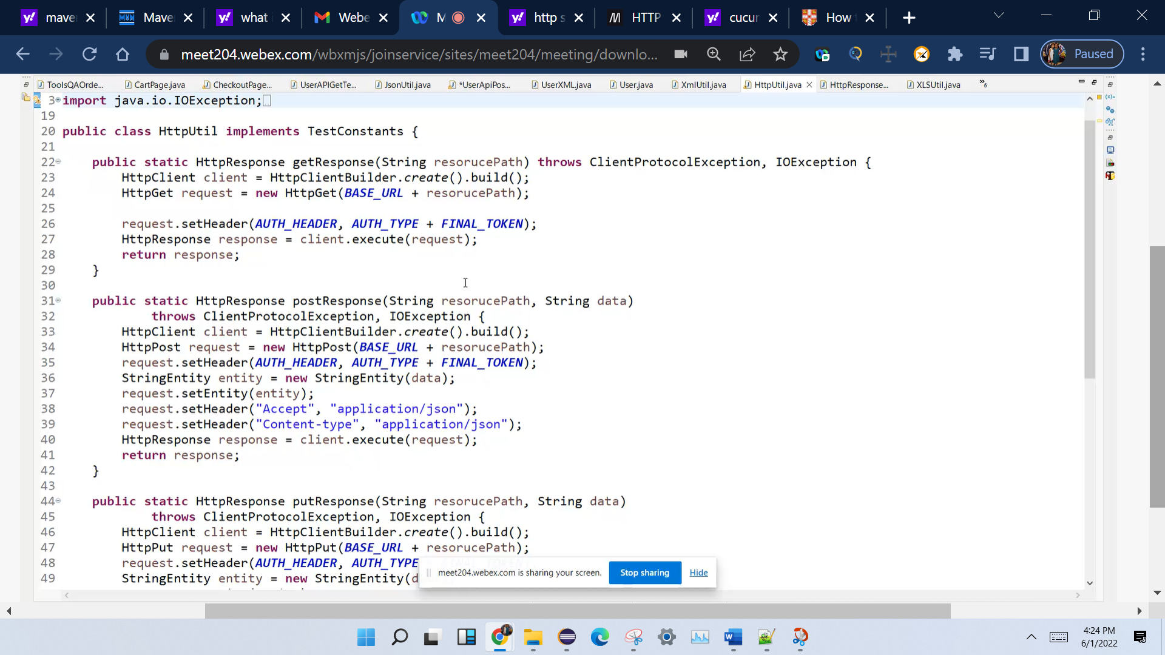

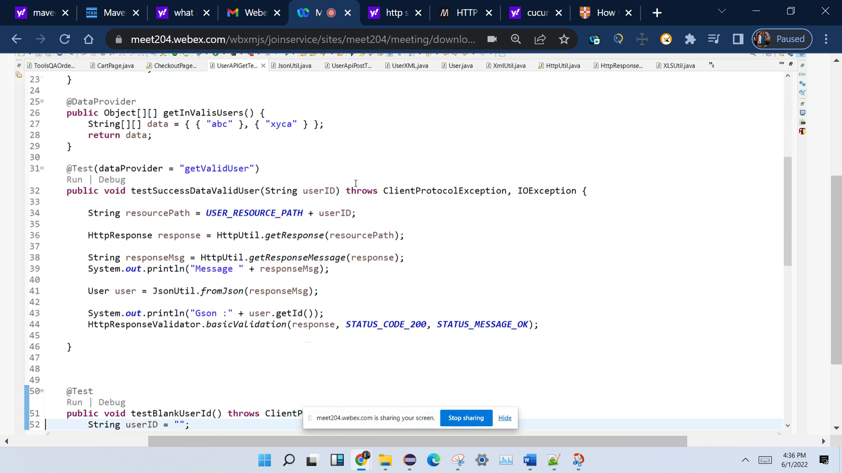

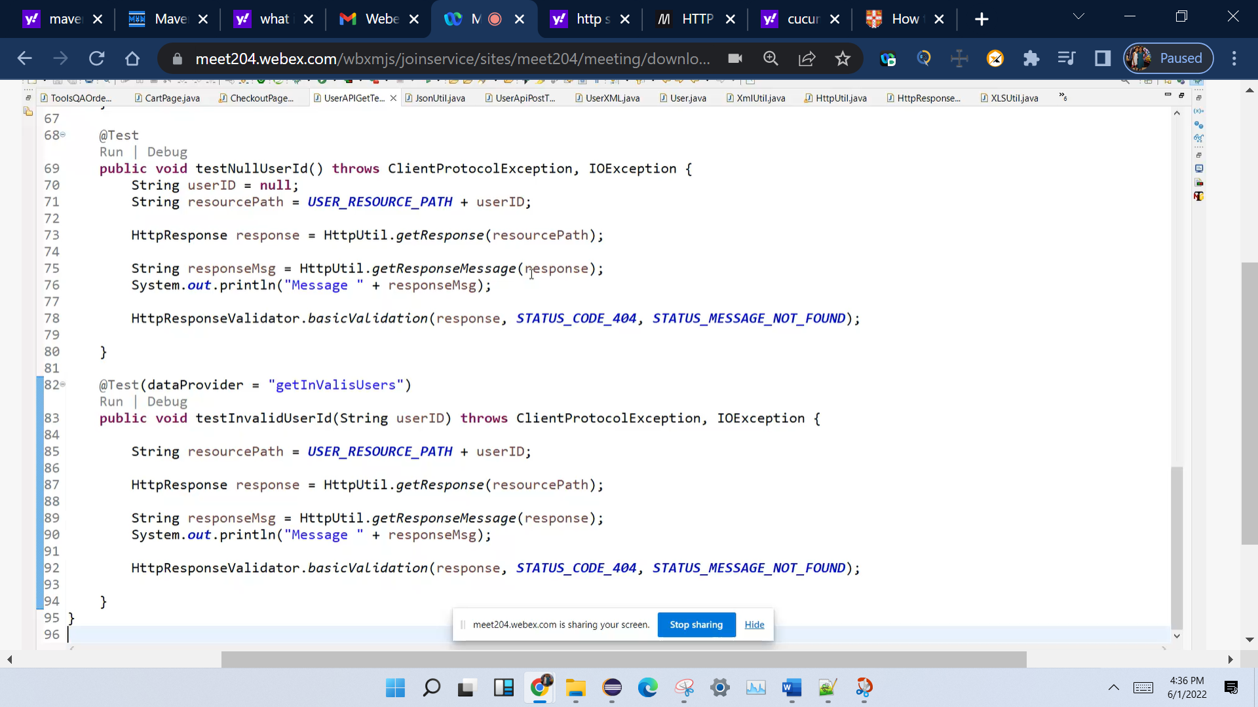

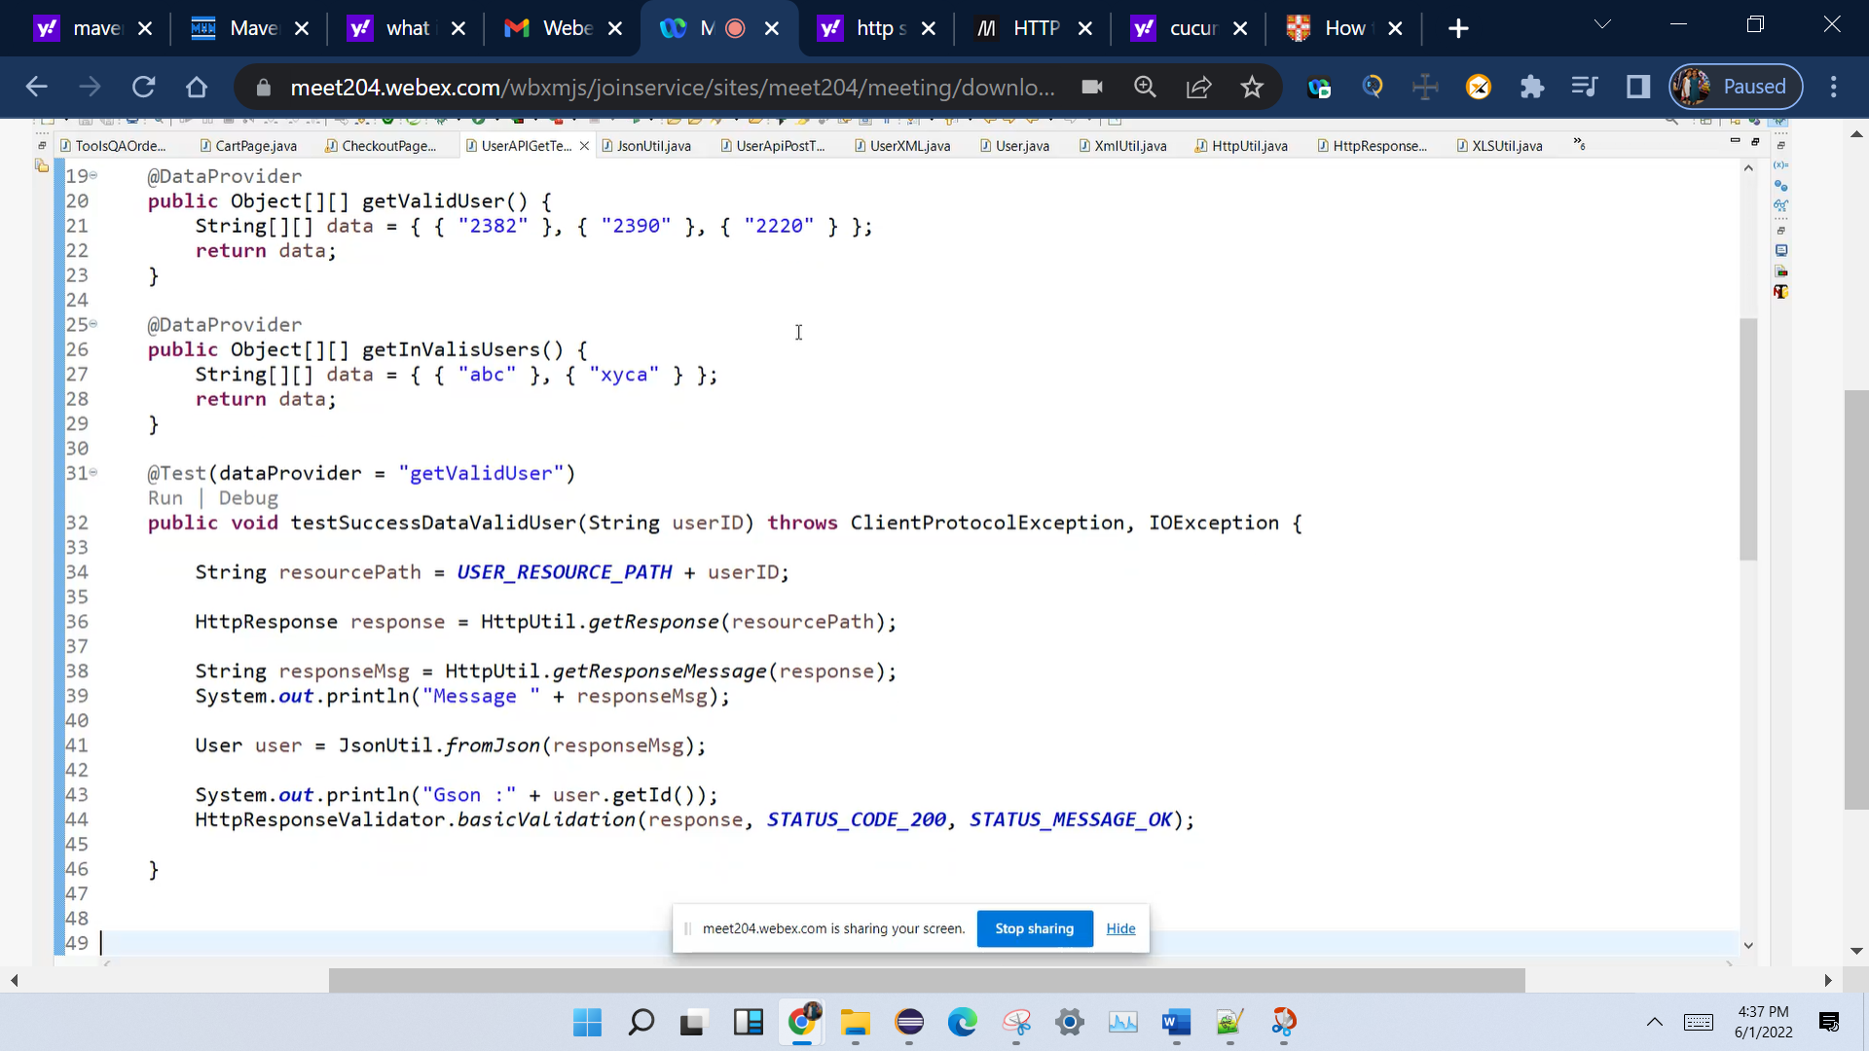

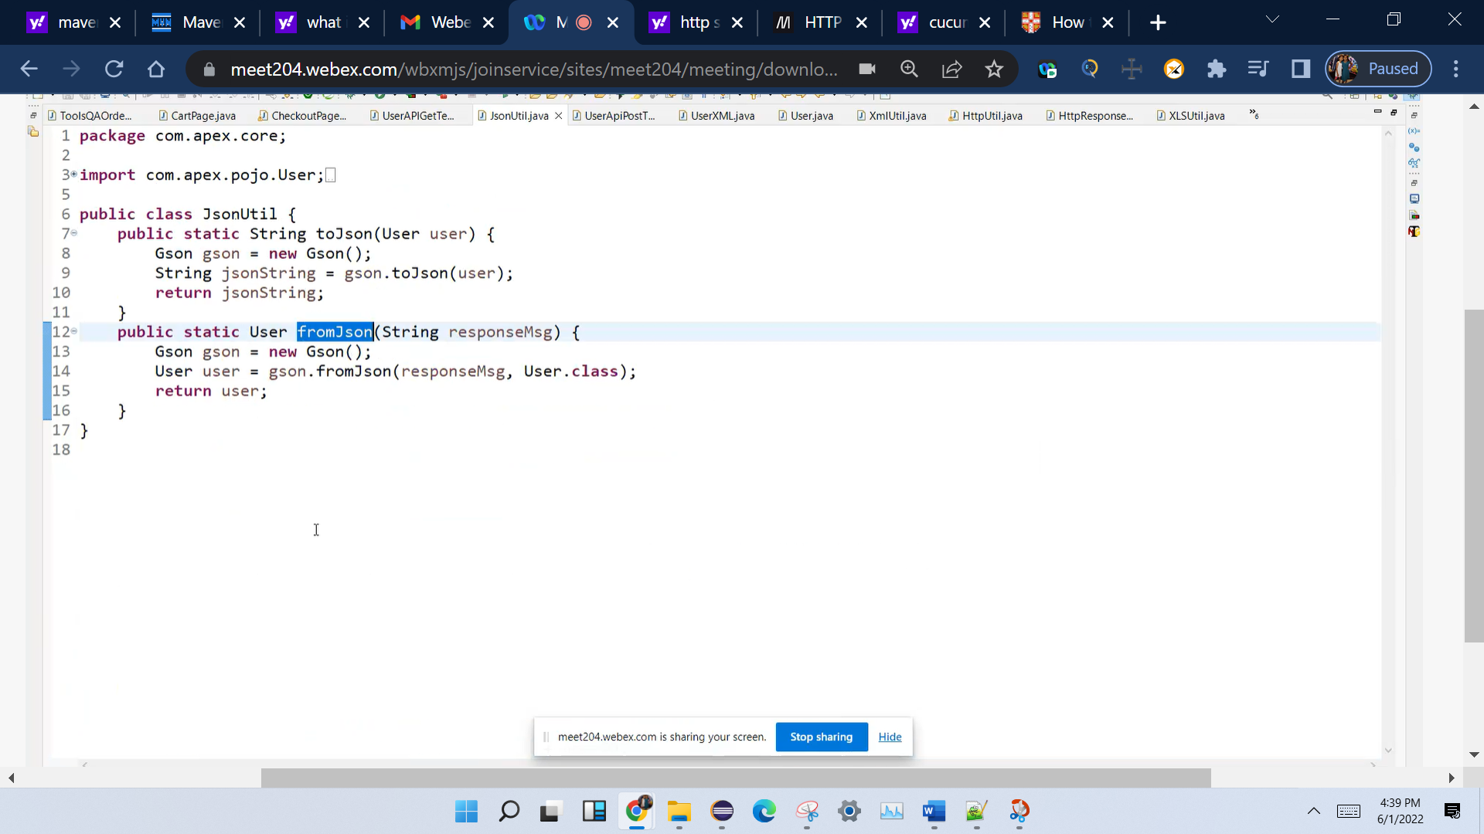

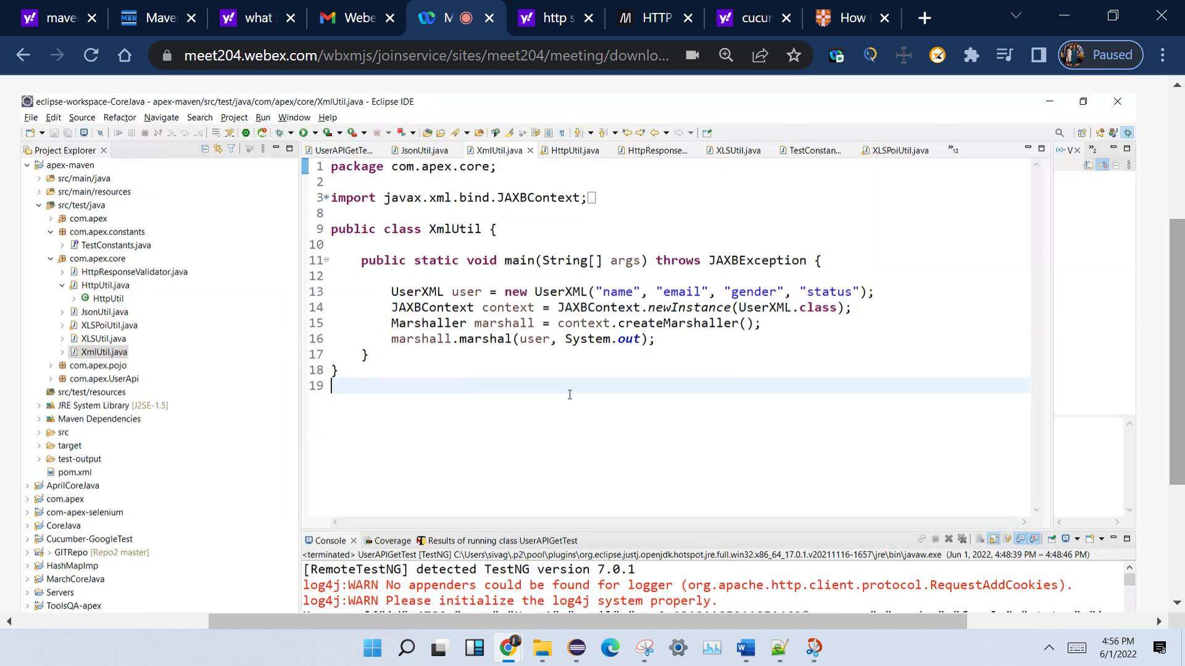

Marsheller vs unmarshalling